Breast Cancer Awareness Month

October is Breast Cancer Awareness Month. Breast cancer is the second-leading cause of cancer death for women in New York City.

Take the steps below to reduce your risk of breast cancer and detect it early:

REDUCE YOUR RISK:
- Maintain a healthy weight by getting enough physical activity and eating a healthy diet. Adults should get at least 30 minutes of physical activity, five days a week. Choose high-fiber foods like fruits, vegetables, beans and whole grains to feel fuller longer and on fewer calories. Overeating and doing little physical activity can lead to excess weight and health problems, including cancer.
  - Check out the Guide to Healthy Eating and Active Living in NYC to learn simple steps for creating healthy habits.
  - Try a Shape Up NYC class. Shape Up NYC offers free fitness classes in all five boroughs. Registration is not required. Find a workout class at nyc.gov/shapeupnyc.

- Avoid drinking alcohol. If you drink alcohol, cut back as much as you can. Drinking even a small amount of alcohol can increase your risk of breast cancer.
  - If you think you or someone you care about has a problem with alcohol, help is available from the City and from the NYC Employee Assistance Program (EAP).

GET SCREENED:
Getting a mammogram can help find breast cancer early when it is more treatable. If you are 40 years or older, talk to your doctor about the best time for you to get screened. If you have a family history of breast cancer, talk to your doctor before age 40.
- Excused Absence: City employees are eligible for four hours of excused leave for breast cancer screening annually. This allows employees to take a paid leave of absence for necessary cancer screenings.
  - This provision does not mean that breast cancer screenings are mandatory or essential for everyone or that screenings for other cancers are less important.

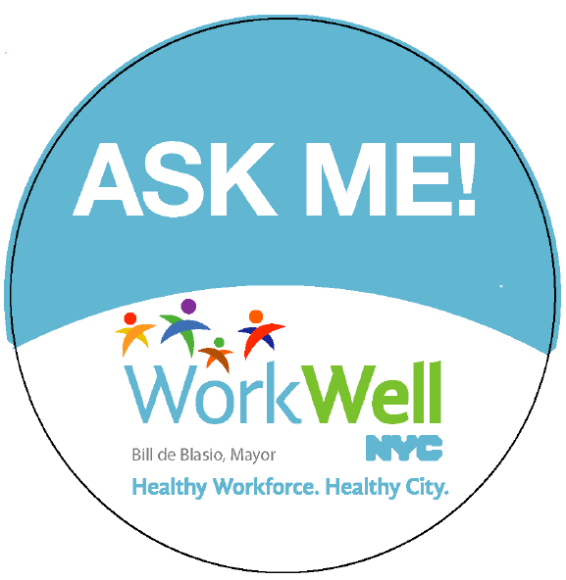 | Interested in becoming a WorkWell NYC Champion?  Click here to learn more and sign up!

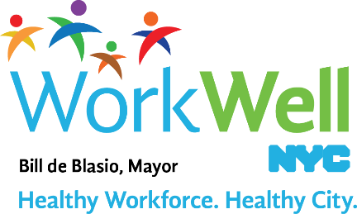

www.nyc.gov/workwellnyc| workwell@olr.nyc.gov

