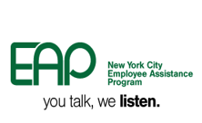 | 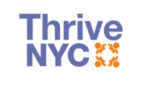 | 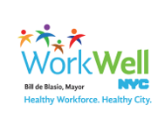

Many New Yorkers may be feeling distressed or vulnerable following the election results. We have seen the concerns expressed on social media and we are monitoring them closely.

In light of these concerns, the Office of the Deputy Mayor for Strategic Policy Initiatives and Thrive NYC have partnered with the Mayor's Office of Immigrant Affairs (MOIA), the Department of Health and Mental Hygiene (DOHMH), the Department of Education (DOE), the Department of Youth and Community Development (DYCD), the Office of Labor Relations' Employee Assistance Program (OLR EAP), providers and others to share information and resources and to provide support. We hope to maintain resilience, raise awareness of symptoms to support early intervention, and provide information about available resources, including NYC Well, the City's 24/7/365 connection to care, which offers with interpretation services in over 200 languages. NYC Employees can also call the EAP at 212-306-7660 for support.

We are also doing additional outreach and media to share information, as well as community engagement through convenings and conversations. DOE is also developing supportive activities in schools and working with Thrive NYC's School Mental Health Consultants program to promote our students' mental wellness.

For more information, please refer to the following resources:
- NYC Well Fact Sheet
- Coping with Stressful Events
- Mayor's Office of Immigrant Affairs Reference Sheet
- Helping Children and Youth Cope
- Tips for Self-Care and NYC Employee Assistance Programs
We will continue to support our fellow New Yorkers and promote mental wellness through interagency collaboration and the provision of mental health services. Thank you for your continued service.

Please do not reply to this message.

