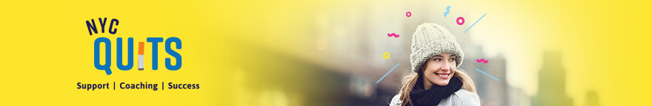
On Thursday, November 16, smokers across the nation will take part in the American Cancer Society’s “Great American Smokeout.” This is a great opportunity to quit, or to encourage someone you know to quit smoking even just for that day.

By quitting – even for one day – smokers will be taking an important step toward a healthier life and reducing their risk of cancer and heart disease.

Quitting smoking can help you:

- Breathe more easily
- Save money
- Have an improved sense of smell
- Have clearer skin
- Have whiter teeth
- Have a better sense of taste
- Have more energy
- Have fewer sick days
- Have better breath
- Have a healthier and longer life
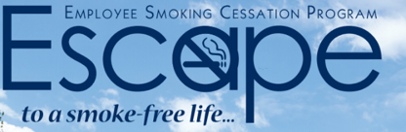
Need help? Call 347-396-2878 to enroll in the Employee Smoking Cessation Assistance Program (ESCAPE), which is available to ALL New York City government employees and their families.

ESCAPE offers the following quit-smoking support, FREE of charge:
- Medications (nicotine patch, gum and lozenge, Zyban® (bupropion) and Chantix® (varenicline))
- Confidential counseling provided by trained specialists in-person or by phone

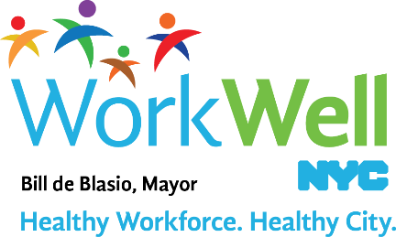

www.nyc.gov/workwellnyc| workwell@olr.nyc.gov

