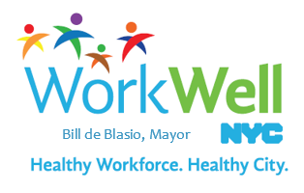

Celebrate Women’s Health Awareness Week and National Stroke Awareness Month with Preventive and Early Detection Screenings

Did you know that beginning July 1, 2016 many preventive screenings will be available for FREE for all employees enrolled in the EmblemHealth GHI CBP plan?

In recognition of National Stroke Awareness Month and Women’s Health Awareness Week we encourage you to take advantage of these no-cost preventive screenings as a key strategy in your own wellness.

- Stroke is a leading cause of preventable death. Find out if you’re at risk by asking your physician if you have high blood pressure so you can take action and protect your health.

- Preventive and early detection screenings are also available at $0 co-pay for health conditions such as breast cancer, cervical cancer, HIV, diabetes, sexually transmitted infections, and colorectal cancer, among others.

- Ask your physician if it’s a good time for you to schedule screenings like a colonoscopy, a blood glucose test, or a cholesterol level test.

For additional information about health insurance plan improvements or other preventive services offered at $0 co-pay, please visit the Office of Labor Relations website.

Do not reply to this message.

