September is National Recovery Month

Problems with alcohol or drugs can affect anyone. The good news is that substance use problems are treatable.
REDUCE YOUR RISK OF ADDICTION and HEALTH PROBLEMS from prescription painkillers, alcohol or other drugs with these tips:
- Take medications as prescribed.
- If you consume alcohol, avoid drinking on an empty stomach; alternate alcoholic drinks with water.
- Avoid mixing drugs, whether prescribed or not. You're more likely to overdose if you combine an opioid, like a prescription painkiller or heroin, with other substances like alcohol or benzodiazepines.
- It is especially dangerous to take drugs that are not prescribed to you. Illegally made fentanyl, a drug that is 50 times more powerful than heroin, is being mixed into heroin, cocaine, pills marked as Xanax and other drugs. It was responsible for nearly half of the overdose deaths in NYC last year. A third of the fentanyl-related overdose deaths resulted from mixing cocaine and fentanyl without the presence of heroin.
For additional tips, please click here.

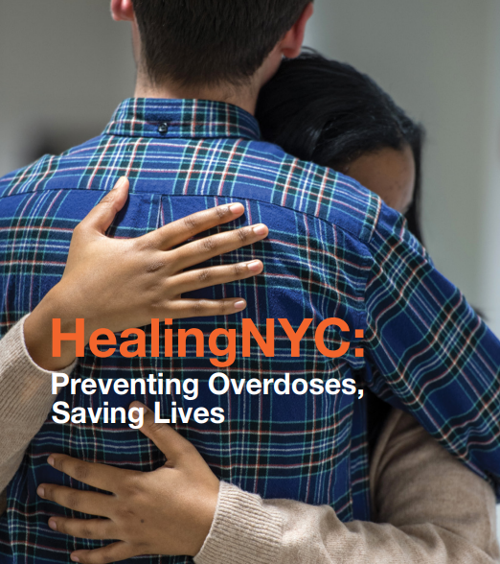

FIND HELP FOR YOURSELF OR OTHERS: If you think that you or someone you care about has problems with prescription medications, illicit drugs or alcohol, help is available.
- The NYC Employee Assistance Program (EAP) offers free and confidential assistance to employees and family members. If treatment is necessary, the EAP can assist in making a referral to a provider covered by your health benefits. Call the EAP at 212-306-7660 or email eap@olr.nyc.gov.
- NYC Well is a free, confidential helpline, available 24/7: call 1-888-NYC-Well or text “WELL” to 65173.
- Medication treatment for opioid use disorder and alcohol use disorder is highly effective. Learn more about drug and alcohol use services here, or talk to your doctor. (If you don’t have a primary care provider, please follow this link to find one in your network, or call 311.)
SAVE A LIFE! PREVENT OVERDOSE: If you know people who use opioids, including heroin or prescription painkillers, learn to recognize the signs of overdose. A medication called naloxone reverses the effects of opioids and prevents overdose deaths. To prevent overdose:
- Get naloxone. It is available by prescription from your doctor or without a prescription at more than 700 participating pharmacies in NYC. Use our site locator or download a searchable PDF to find a nearby pharmacy.
- If you see a person who may be overdosing, call 911 and give them naloxone if you have it.
- Most insurance plans cover naloxone. It is also available for free at participating community-based programs throughout the city.
- Learn more about overdose prevention here or download NYC’s StopOD free mobile app (for Android or IOS).

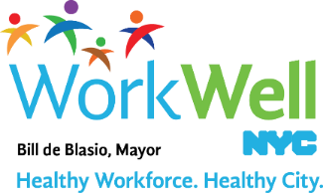

www.nyc.gov/workwellnyc | workwell@olr.nyc.gov

