School’s out, the weather’s hot and the days are long – summer is finally here!
Whether your summer plans include a cross-country weeklong journey or just a Saturday trip to the beach, don’t let your travel derail your healthy habits. WorkWell NYC and Weight Watchers are partnering to help you stay healthy this summer. Check out these tips to help you stay healthy on vacation:
- Come prepared: Don’t fall victim to temptations at the gas station or the airport. Take a few minutes to pack some fruit or nuts – you’ll feel better and your wallet will thank you, too!
- Hydrate, hydrate, hydrate: You already know how important staying hydrated is, but it can be difficult to keep up your water intake when you’re out of your normal routine. Bring a reusable water bottle with you when you travel to help remind yourself to drink water.
- Stretch it out: Whether by car, train or plane, traveling can literally be a huge pain in the neck. Take breaks to walk around and stretch out your muscles, just like when you’re working at your desk. Even if you’re confined to a small space, a little bit of movement can go a long way.
- Walk everywhere: Get your exercise and see the sights at the same time! Walking is one of the best ways to take in a new destination –and you never know what other things you might see.

Heading to a picnic with friends and family? Throw together this fresh salad for only 4 SmartPoints™!
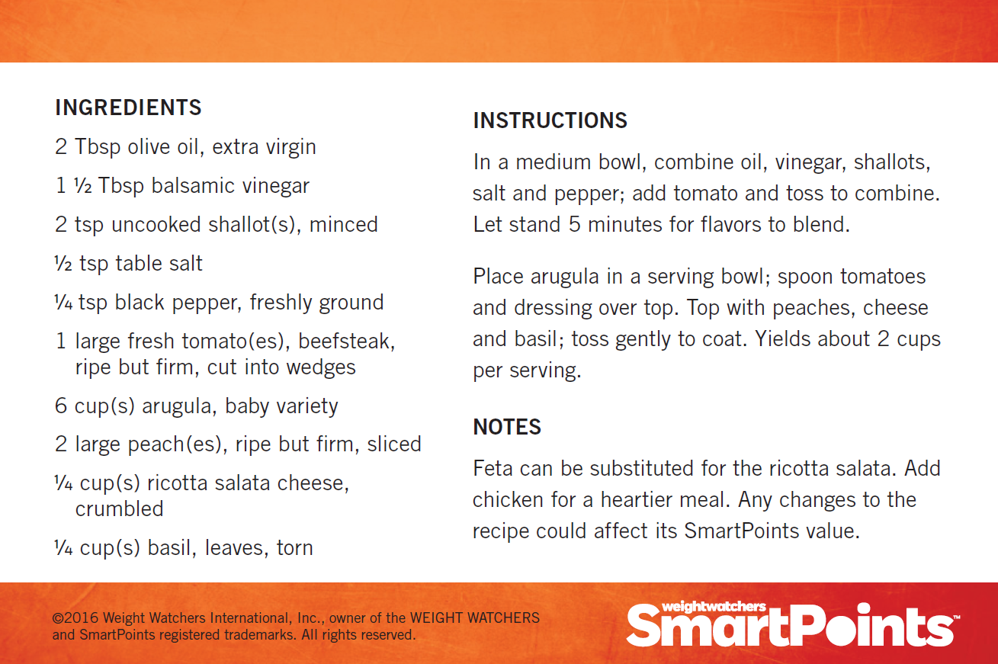

By enrolling through the City’s Weight Watchers program, employees can take advantage of a subsidy that reduces the cost of membership by more than 50% off the regular membership price*. Spouses/domestic partners, dependents (ages 18-26) and retirees** are also eligible for discounted pricing through the WorkWell NYC partnership with Weight Watchers – making health a family affair!

Weight Watchers Offering | NYC Employee Special Pricing
Meetings (Includes OnlinePlus) at work or in your local community | $15.00 per month
OnlinePlus | $7.00 per month

Visit nyc.join.weightwatchers.com to learn more about Weight Watchers and sign up today!
* The dollar value of this contribution/benefit will be included as taxable income to the employee.
** Spouses and dependents of retirees are not eligible for the discount.

