NYC Farmers Market Season Has Arrived!

Enjoy the delicious produce our region has to offer.

Visit a farmers market near you to fuel up on fruits and vegetables, participate in a healthy cooking workshop or try a sample of an easy, seasonal recipe.

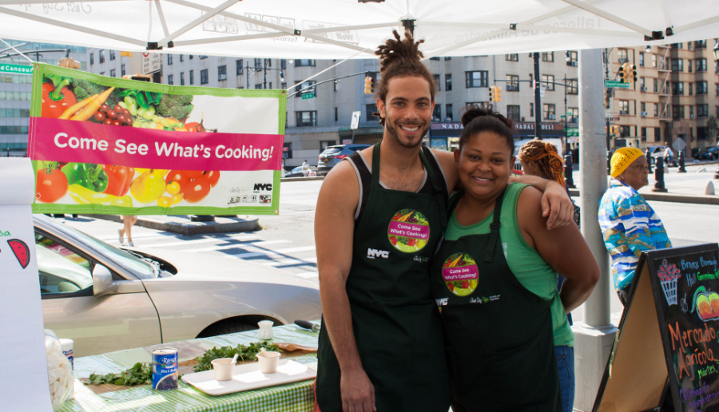

Did you know that eating fruits and vegetables every day can lower your risk of heart disease, obesity, diabetes and some cancers? Fruits and vegetables keep us healthy because they:

- Contain plenty of fiber
- Are naturally low in sodium
- Are important sources of many vitamins and minerals

NYC farmers markets are a fun outdoor venue for purchasing delicious, fresh, seasonal produce.

  - Text “SoGood” to 877877 or use this map to find a farmers market near you.
  - Participate in the Health Department’s public cooking demonstrations from July through November. Attendees will receive a $2 Health Bucks coupon to spend on fruits and vegetables at the market! Look for the carrot icon on this map to find locations with cooking demonstrations.
  - Use the Health Department’s recipes to prepare an easy and inexpensive healthy dish.
  - Stay Hydrated! Water is healthy and has zero calories. Find pop-up water fountains in NYC by visiting nyc.gov or downloading the free NYC Water app, available here. NYC tap water tastes great and best of all, it is free!

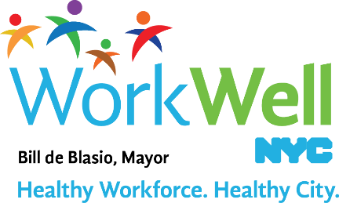

www.nyc.gov/workwellnyc | workwell@olr.nyc.gov

NYC DOHMH Guide to Healthy Eating and Active Living in NYC.

