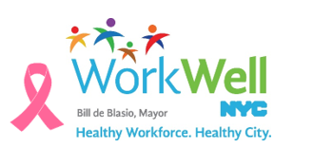
WorkWell NYC recognizes October as Breast Cancer Awareness Month. Breast cancer is one of the most common cancers in women of all races and ethnicities.^{i} Routine screenings are important in early detection and treatment of breast cancer since some women who have breast cancer do not have any signs or symptoms.

DID YOU KNOW?
Breast cancer killed more than 1,000 women in NYC in 2014.^{ii}

Screening can detect cancer early, when it is more treatable. The United States Preventive Services Task Force recommends the following:
- Women who are 50 to 74 years old should get a screening mammogram every two years.
- Women who are 40 to 49 years old should talk with their provider about when to start and how often to get a mammogram.
Ask your provider about the benefits and risks of breast cancer screening for you. You may have other risk factors that your provider will need to consider.
Most health plans that insure NYC employees and their family members cover low- or no-cost preventative screenings.
*Anyone with signs or symptoms of breast cancer should talk with their doctor right away.
WorkWell NYC wants you to work, live and be healthy. Take the necessary steps to get screened or to support your loved ones in getting screened. Please join WorkWell NYC tomorrow, October 21st in wearing pink in recognition of Breast Cancer Awareness Month.

^{i} CDC Breast Cancer Statistics: https://www.cdc.gov/cancer/breast/statistics/index.htm
^{ii} Lu W, Huynh M, Lee E. Summary of Vital Statistics, 2014. New York, NY: New York City Department of Health and Mental Hygiene, Office of Vital Statistics, 2016.

