Raising Healthy Children

August is the time when parents prepare their children to go Back to School and is also National Breastfeeding Month. You’re there for your littlest New Yorkers, and we’re here for you. WorkWell NYC encourages City employees to check out all of the resources available for parents and caregivers in NYC!
Resources for parents of older children:
- All new students - entering child care through grade 12 in NYC for the first time – must receive and show proof of certain vaccines and a medical evaluation. Download a Physical Examination Form (CH-205) to bring to your child’s pediatrician, and learn more about required vaccinations online or by calling 311.
- Back to School Forms: Make sure your child is able to receive their daily medication at school. Have their pediatrician fill out a Medical Administration Form and return it to your child’s school nurse. Fill out a special form if your child has asthma or diabetes.
- Growing Up NYC: Check out Growing Up NYC, the official program and event resource for NYC-area children of all ages.

Tips for new parents:
- Breastfeeding? Keep it up! Breast milk gives your baby the best start in life.
- Talk, read and sing to your baby, right from birth. Words help build the brain!
- Always put your baby down to sleep alone, on their back, in a crib or bassinet.
  - Remove pillows, bumpers, stuffed toys and blankets to protect them from suffocation risks.
- Keep your home smoke- and pest-free.
- Keep your baby away from peeling paint and repair work to make sure they stay healthy and safe.
- Take care of you! Eat well, exercise and spend time with friends and loved ones.
When you are happy, your baby is happy, too!

Resources for new and expecting parents:
- Thinking about breastfeeding? Mobile Milk is a text messaging service that provides free breastfeeding support and information starting in your third trimester until your baby is 4 months old. Join any time by texting “MILK” to 877877.
- Learn more about the Employee Lactation Program. Employers are required by law to provide a private, non-bathroom location and reasonable time for employees to express or pump breast milk for their babies when they return to work.
- You have a right to breastfeed anytime, anywhere. Visit nyc.gov/health and search “breastfeeding” to find a community lactation room near you.
- If you need a crib for your baby but can’t afford one, call 311 to see if you may be eligible for a free crib through one of the City’s Safe Sleep programs.
- Child Care Connect can help you find child care outside your home. You can also call 311 for assistance.
- If you’re worried about your baby’s development (i.e., if they are not smiling or making eye contact after three months) tell your doctor and learn more about the Early Intervention Program.

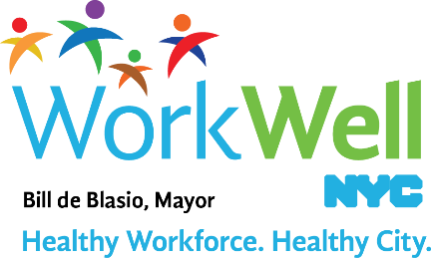

www.nyc.gov/workwellnyc | workwell@olr.nyc.gov

