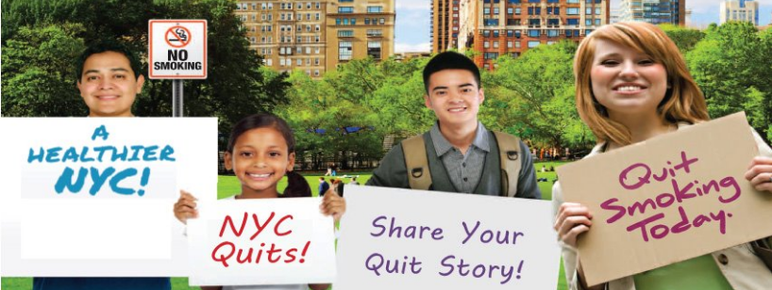

Today, smokers across the nation are taking part in the American Cancer Society’s “Great American Smokeout” event. This is a great opportunity to quit, or to encourage someone you know to quit smoking.

By quitting – even for one day – smokers will be taking an important step toward a healthier life and reducing their risk of cancer and heart disease.

Quitting smoking is hard, but it will help you get one step closer to good health. For example:

- After 20 minutes smoke-free: | Your heart rate and blood pressure drop to a healthier level
- After 8 hours smoke-free: | Your blood-oxygen level returns to normal
- After 12 hours smoke-free: | The carbon monoxide level in your blood drops to normal
- After 2 days smoke-free: | Your heart attack risk begins to drop
- After 3 days smoke-free: | Your ability to smell and taste improves
- After 2-3 weeks smoke-free: | Your lung function improves
- After 3 months smoke-free: | Your lung function improves by up to 30%
- After 1 year smoke-free: | Your risk of heart disease is cut in half

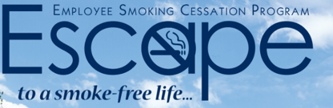
Need help? Call 212-676-2393 to enroll in the Employee Smoking Cessation Assistance Program (ESCAPE), which is available to ALL New York City government employees and their families.

ESCAPE offers the following quit-smoking support, FREE of charge:
- Medications (nicotine patch, gum and lozenge, Zyban® (bupropion) and Chantix® (varenicline))
- Confidential counseling provided by trained specialists in-person or by phone
Call 212-676-2393 for an appointment.
*If you get the ESCAPE voicemail, please leave a message with your name and phone number and an ESCAPE counselor will call you back within 2 days.
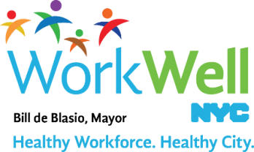
nyc.gov/workwellnyc | workwell@olr.nyc.gov

