Did you know?

- 1.3 million adult New Yorkers have prediabetes.
- Prediabetes means that your blood glucose (sugar) levels are
higher than normal, but not yet high enough to be called
diabetes.

- More than 700,000 adult New Yorkers have diabetes.

- Many people don’t know they have prediabetes or diabetes.
- For example, nearly 90 percent of adult Americans living with
prediabetes don’t know they have it.

WorkWell NYC and our City health insurance plans offer programs for employees with prediabetes or diabetes:
- National Diabetes Prevention Program (NDPP): This free program helps people who are overweight and at risk for developing diabetes delay or avoid developing it in the future.
  - Take this risk test to find out if you may have prediabetes. Discuss your results with your health care provider and email WorkWell NYC to learn about free NDPP classes available to City employees. If you don’t have a health care provider, click here to find one in your network.
- Case Management Program: In this program, nurses and social workers provide personalized support to individuals covered by EmblemHealth City Health plans and living with diabetes, or currently experiencing gestational diabetes.*
*Gestational diabetes is diagnosed when a pregnant woman has high blood sugar levels during pregnancy. It may go away after giving birth but increases the risk of diabetes later in life.
- Call the number on your EmblemHealth insurance card to learn more, or call your insurance carrier to learn about other programs.

Whether you are at risk for diabetes or not, the following can improve your health:
Get regular physical activity at least 30 minutes a day, five days a week:
- Shape Up NYC offers free fitness classes in all five boroughs. Registration is not required. Find a workout class near you at nyc.gov/shapeupnyc.
- Make NYC your gym and check out some of NYC’s landmarks along thousands of miles of sidewalks, walkways and green spaces.
Eat a healthy diet with more vegetables and fruits, and fewer sweets and sugary drinks:
- Visit a farmers market near you for locally grown, seasonal produce.
- Check out the Guide to Healthy Eating and Active Living in NYC. This guide provides steps to create healthy habits, and tips to save money, lose weight, manage stress, gain more energy and set a good example for your children/family.

WorkWell NYC wants to help you and your family stay healthy. For more information on these and other resources for City employees, visit WorkWell NYC or email us at workwell@olr.nyc.gov.

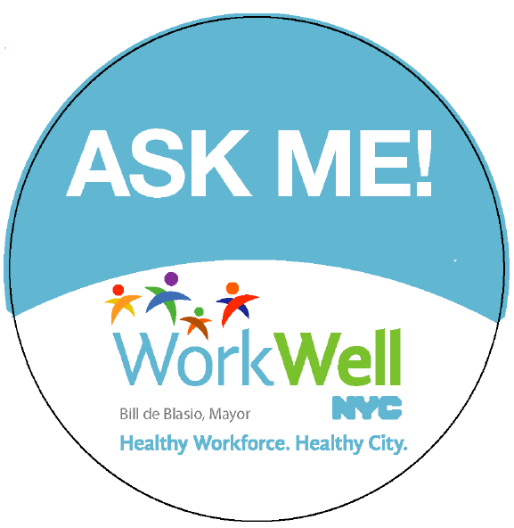 | Interested in becoming a WorkWell NYC Champion?  Click here to learn more and sign up!
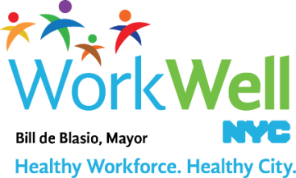

www.nyc.gov/workwellnyc| workwell@olr.nyc.gov

