[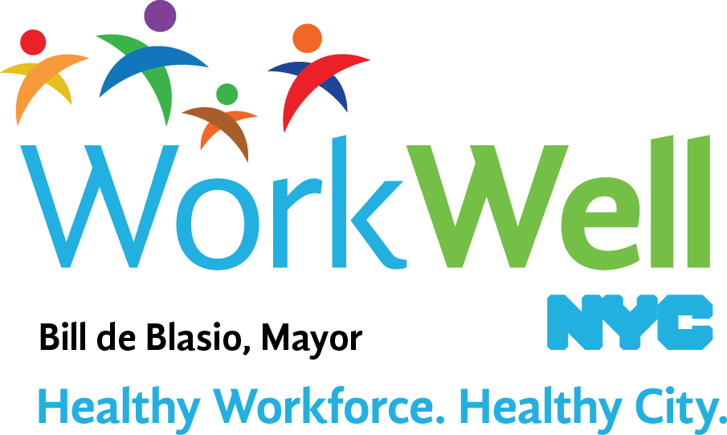](http://www.nyc.gov/workwellnyc)

Celebrate the American Cancer Society’s **Great American Smokeout** on November 17. Join other New Yorkers in stopping smoking for just one day, as a first step towards quitting for good.

New York City government is here to support your efforts to quit smoking. **City government employees can enroll in the Employee Smoking Cessation Program (ESCAPE) and receive personalized, confidential counseling and smoking cessation medications for free.** Learn more [**here**](https://www1.nyc.gov/site/doh/health/health-topics/smoking-escape-employee-smoking-cessation-assistance-program.page). Call 212-676-2393 to enroll.

**Quit Smoking: Small Daily Steps Add Up**

|  |  |
| --- | --- |
|  | **WAKING UP:**   * Don’t linger in bed - cravings can start as soon as you wake up. Instead, get up and shower right away. * If you need to stay in bed, keep straws, flavored toothpicks, or [**nicotine gum and nicotine lozenge**](https://www.nysmokefree.com/Subpage.aspx?P=20&P1=20310) to help curb cravings. |
|  | **EATING:**   * Enjoy a good book during your breakfast. After breakfast, brush your teeth right away and enjoy the fresh taste. * If morning coffee is a [**trigger**](https://www1.nyc.gov/assets/doh/downloads/pdf/smoke/triggers.pdf), try tea instead. * Since smoking after eating is common, try eating meals slowly. |
|  | **WORKING:**   * Feeling stressed at work? On breaks, walk around the block or [**climb stairs**](https://www1.nyc.gov/assets/doh/downloads/pdf/smoke/exercise.pdf). * If you can't get away, try breathing slowly and deeply. Keep sugar-free mints or cough drops at your desk and/or fruit and veggies in the fridge as alternatives to cigarettes. |
|  | **RELAXING IN THE EVENING:**   * After dinner, avoid boredom (a common trigger) by calling a friend, or enjoying a [**hobby**](https://www1.nyc.gov/assets/doh/downloads/pdf/smoke/hobby.pdf), like knitting or painting. |
|  | **GOING TO BED:**   * Having trouble sleeping? Relax your mind and body by taking a bath, doing some stretches, [**listening to soothing music**](https://www1.nyc.gov/assets/doh/downloads/pdf/smoke/list-music.pdf) or drinking herbal tea. |

**We encourage you to try out these small daily steps to help you quit smoking. Contact the Employee Smoking Cessation Program (ESCAPE) at 212-676-2393 for additional support.**

[http://www.nyc.gov/html/misc/gif/newsletter/stop-smoking-fb-111915.jpg](https://www.facebook.com/nycquits/)[http://www.nyc.gov/html/misc/gif/newsletter/stop-smoking-twitter-111915.jpg](https://twitter.com/hashtag/nycquits)