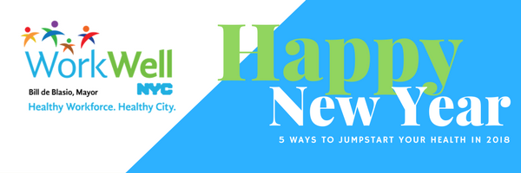
WorkWell NYC has many resources available to support your health goals and to make 2018 the healthiest year yet for you and your family! Below are five ways to jumpstart your health in 2018:
EAT HEALTHY  1 | - Check out the Guide to Healthy Eating and Active Living in NYC to learn how to create healthy eating habits. Try one of these delicious and healthy recipes tonight!  - Choose less sodium when you can. When buying packaged food, use this guide to identify those lower in sodium. Also, look for sodium warning icons at chain restaurants in New York City.  - Take advantage of the discounted Weight Watchers program available to benefits-eligible City employees and their families. Join an at-work meeting for added convenience!
STAY ACTIVE  2 | - Try free Shape Up NYC drop-in fitness classes at community centers throughout the city. You can also find local free and low-cost fitness resources at BeFitNYC.org.
QUIT SMOKING  3 | - Employees and their household members can enroll in the Employee Smoking Cessation Assistance Program (ESCAPE) and receive free personalized, confidential counseling and smoking-cessation medications. Call 212-676-2393 to enroll.  - You can also talk to your health care provider for smoking cessation assistance. If you don’t have a health care provider, click here to contact your health plan to find a provider in your network.
SEEK HELP  4 | - If you feel overwhelmed, talk to a partner, family member or friend, or call the New York City Employee Assistance Program (NYC EAP) for help. The EAP offers free and confidential assistance to employees and family members. You can reach the EAP at 212-306-7660 or by email at eap@olr.nyc.gov.
GET PREVENTIVE CARE  5 | - Many preventive screenings are free for employees with EmblemHealth insurance. Some screenings to consider include breast cancer, cervical cancer, colorectal cancer, HIV, sexually transmitted infections, high blood pressure, and diabetes. Ask your provider about screening benefits and risks.  - If you don’t have a health care provider, click here to find one in your network. For additional information about health insurance plan coverage and preventive services offered at $0 copay, click here.

