Zoning Resolution Text Amendment Guidelines and Template: Appendix F
Version 2.0

Overview

1 Use this template for text amendments that are only proposing to amend
APPENDIX F (i.e., an MIH map proposal) – do not copy and paste existing graphics or text from the Online ZR.

2 Consult with the staff member assigned from the Zoning Division (ZD) for the project who will determine whether there is an existing APPENDIX F map that is being amended or, if relevant, assign the proper scale and details for a new map.

3 Amendments to existing APPENDIX F maps should only be made to the AI (Adobe Illustrator) files that the ZD staff member will provide.

4 The AI file will be the base file for the project and, ultimately, the ZR (a jpeg file, exported from the AI will be the “working” graphic for the project).

5 When submitting the draft text amendment for review, or when filing the Land Use Application, be sure to include:
(a) a Word document with properly formatted amended text, and
(b) the AI file with the proposed amendment.

6 All text and graphic elements, including, where relevant, other text besides an APPENDIX F text amendment, should be contained in a single Word document.

- - - - - - - - - - - - - - - - - - - - - - - - - - - - - - - - - - - - - - - - - - - - - - - - - - - - - - - - - - - - - - - -

TITLE OF PROJECT [italic, bold, centered]

[Month, day, year]

Matter underlined is new, to be added;
Matter struck out is to be deleted;
Matter within # # is defined in Section 12-10;
* * * indicates where unchanged text appears in the Zoning Resolution.

APPENDIX F
Inclusionary Housing Designated Areas and Mandatory Inclusionary Housing Areas

BOROUGH NAME

* * *

Community District XX

* * *

Map XX - [date of adoption]

[EXISTING MAP]
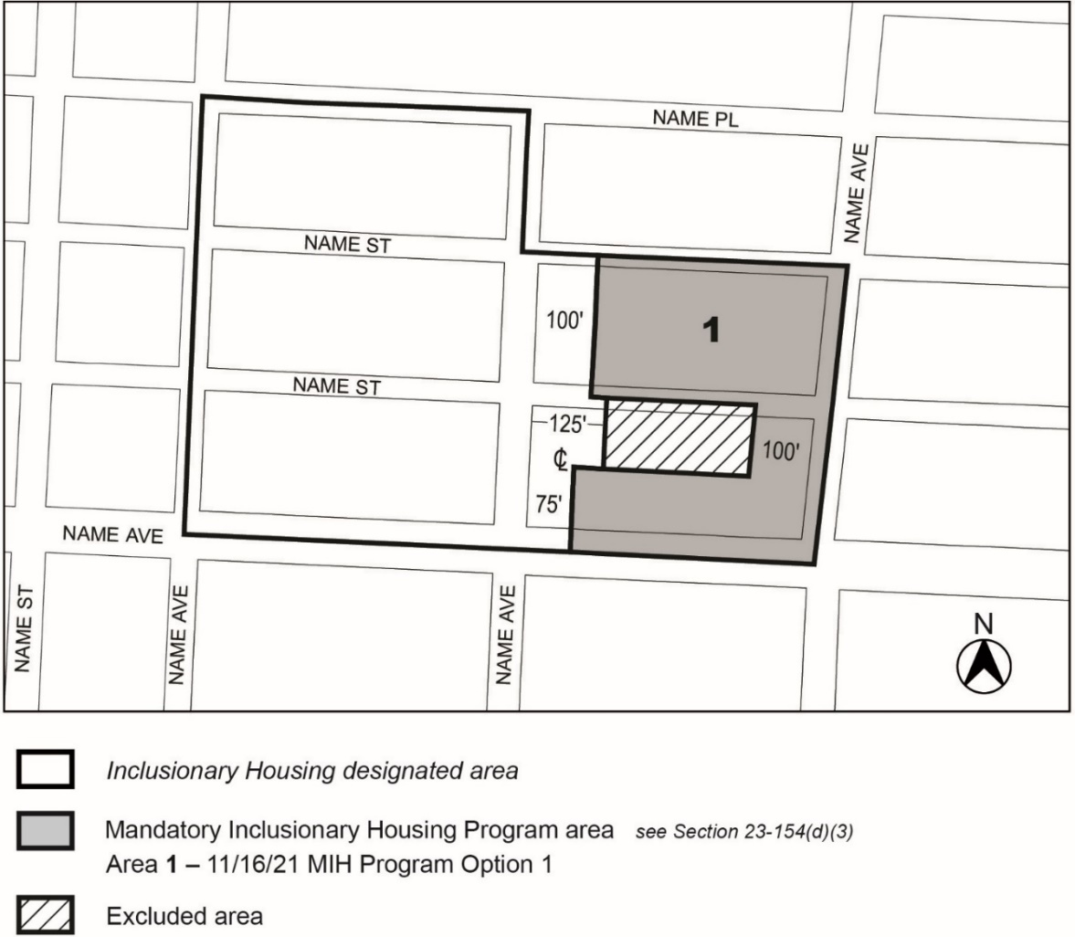

[PROPOSED MAP]

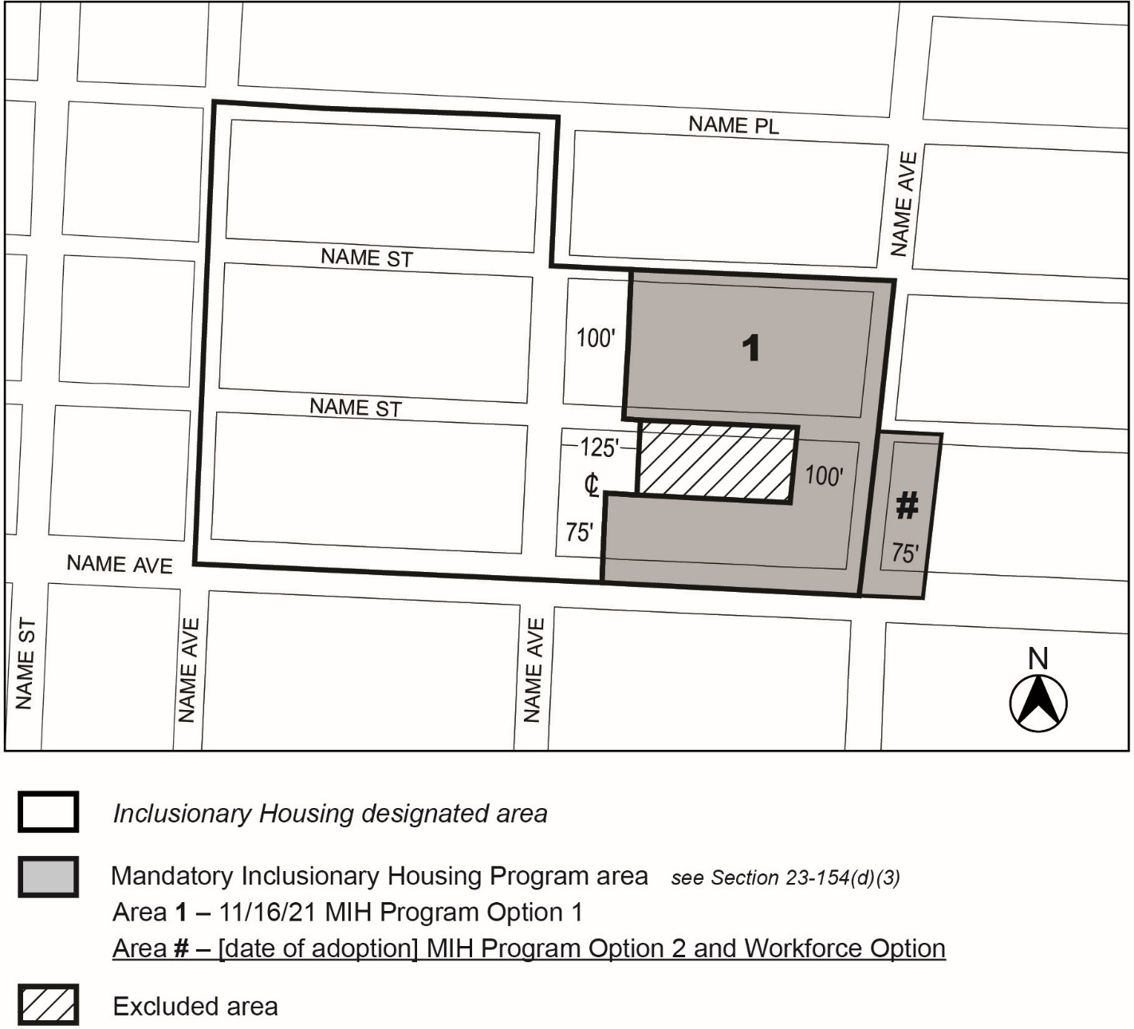Portion of Community District XX, Borough

* * *

