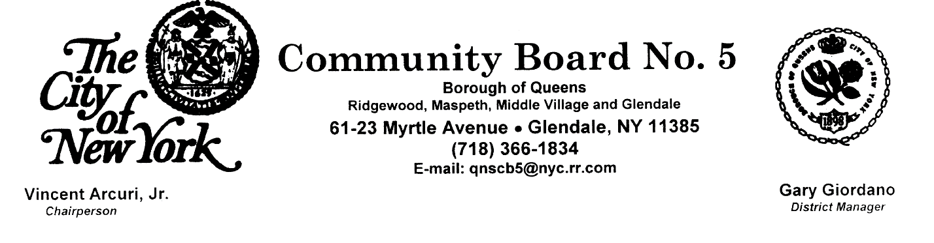
10/10/2016
GG, DM

PUBLIC HEARINGS NOTICE & BOARD MEETING NOTICE
Date : Wednesday, October 19, 2016 (7:30pm)
Place: Christ the King High School Cafeteria
68-02 Metropolitan Avenue, Middle Village, NY 11379

AGENDA

7:30pm Salute to the Flag

7:35pm PUBLIC HEARING I Re: Application # C170079 PCQ
IN THE MATTER OF an Application to the NYC Planning Commission by the NYC Dept. of Health and Mental Hygiene and the Dept. of Citywide Administrative Services, pursuant to Section 197-c of the NYC Charter, for the site selection and acquisition of property located at 72-42 60 Lane, (B: 3590, L: 42), in Glendale, NY for storage use and related program uses.

7:55pm PUBLIC HEARING II Re: BSA Cal No. 2016-4222 BZ
IN THE MATTER OF an Application to the NYC Board of Standards and Appeals by Mango & Iacoviello, LLP, Attorneys at Law, on behalf of Omar A. Alabed, the owner of record, for a variance, under Sections 72-21 and 23-461 (b) and (c) of the NYC Zoning Resolution, to permit the proposed construction of a zero lot line, residential two-family home, contrary to side yard requirements, in an R4-1 Zoning District, at 57-40 Mazeau Street (Block: 2798, Lot: 138) in Maspeth, Queens, NY.

8:15pm PRESENTATION Re: Conflicts of Interest Law

8:30pm PUBLIC FORUM

8:50pm Chairperson’s Report - Vincent Arcuri, Jr.
(including: Review of Minutes of the Sept. 14, 2016 Board Meeting; Review of Current
Applications for the Sale of Alcoholic Beverages Locally; Review of Current Notifications
for Building Demolitions; and Recommendations for CB5Q’s Capital and Expense Budget
Priorities for Fiscal Year 2018.

9:10pm District Manager’s Report - Gary Giordano

9:15pm Committee Reports

Zoning and Land Use Review
Transportation Services
Other Committee Reports

9:25pm Old & New Business

- Times Are Approximate -

