NYC Civic Engagement Commission: Proposed Methodology for Poll Site Interpretation Services
What are we proposing?
The New York City Civic Engagement Commission (NYCCEC) is proposing a methodology for interpretation services at poll sites. The methodology explains how the NYCCEC will identify the languages and locations in which interpretation services will be offered during the November 2020 election and beyond. These services will supplement the interpretation assistance provided by NYC Board of Elections (NYCBOE) in several languages.
What and where is the hearing?
NYCCEC will hold a public hearing on the draft methodology in February 2020. The hearing will take place at 4pm on February 18, 2020. It will be held at 1 Centre Street, 9th Floor, Landmarks and Preservations Room.
How can I comment on the proposed methodology?
The Comment period will be open beginning on January 1, 2020 and ending on March 1st, 2020. Anyone may comment on the proposed methodology by:
- Website: You can submit comments to CEC through the Commission’s website by filling out the comment form.
- Email: You can email written comments to gkaur@civicengagement.nyc.gov
- Mail: You can mail written comments to NYC Civic Engagement Commission, 255 Greenwich St., 9th Floor, New York, NY, 10007, Attn: Gagan Kaur
- By speaking at the in-person hearing: Anyone who wishes to comment on the proposed methodology must sign up to speak. You can sign up before the hearing by emailing info@civicengagement.nyc.gov or calling (646)-769-6032, or you can sign up in the hearing room before the hearing begins on February 18, 2020. You can speak for up to three minutes.

Is there a deadline to submit written comments?
The deadline to submit written comments is February 18, 2020.
What if I need assistance to participate in the hearing?
The meeting location is accessible to individuals using wheelchairs or other mobility devices. Free induction loop systems and ASL interpreters will be available upon request. Free interpretation services will be available in Spanish and also in additional languages, upon request. Please make any such requests or other accessibility requests no later than 5pm February 11, 2020 by emailing info@civicengagement.nyc.gov or calling (646)-769-6032.
The public can view a live stream of this meeting along with past Commission meetings and hearings on the Commission’s website, in the meetings section.
What authorizes the Civic Engagement Commission to propose this methodology?
The New York City Charter, Chapter 76, requires the Commission to propose a draft methodology on or before January 1, 2020, and post it for public comment for a minimum of 30 days. The final methodology is due on or before April 1, 2020.

NYC CIVIC ENGAGEMENT COMMISSION: PROPOSED METHODOLOGY FOR POLL SITE LANGUAGE ASSISTANCE PROGRAM
Executive Summary
The New York City Civic Engagement Commission (NYCCEC) is charged under Chapter 76 of the New York City Charter with creating a Poll Site Language Assistance Program (Program) that will provide interpreters at New York City poll sites to assist limited English Proficient (LEP) voters with casting a ballot. The NYCCEC must develop a methodology to determine which languages are eligible for services and the poll sites where such services would be provided.
The timeline for establishing the methodology is as follows:

This document is the Proposed Methodology that the NYCCEC is required to publish pursuant to Chapter 76 of the Charter. The NYCCEC will accept public comment on this Proposed Methodology and schedule a public hearing. Such public comment period will be open beginning on January 1, 2020 and ending on March 1, 2020. The public hearing will take place on February 18, 2020 at 125 Worth Street, 2nd floor Auditorium.
Below is a summary of what the NYCCEC is proposing herein:
Determining the Total Number of Poll Sites Served
Interpretation will be provided in poll sites that serve the highest number of eligible CVALEP voters who may need services. The total number of poll sites eligible for the Program will be resource-driven, based on the amount of money allocated for this Program.
Languages Served
The Program will provide services in the following languages:
- Arabic
- Bengali
- Chinese (Cantonese, Mandarin)
- French
- Haitian Creole
- Korean
- Polish
- Russian
- Urdu
- Yiddish
The NYCCEC will provide services in Bengali, Korean, and Chinese (Cantonese, Mandarin) only in counties where the New York City Board of Elections (NYCBOE) is not mandated to provide services in such languages under the federal Voting Rights Act.
Determining the Level of Services for Each Language

Among languages to be served by the Program, the number of poll sites that will receive services in a particular language served will depend on each language’s share of the citizen voting age limited English proficient population (CVALEP) compared to other languages served by the Program. For example, according to U.S. Census data, approximately 211,400 New Yorkers are CVA with LEP and speak a language that is served by this Program. Of that number, 42% speak Russian. Therefore, for example, if NYCCEC is allocated resources to serve 100 poll sites total, interpretation would be provided in Russian in up to 42% of the total number of poll sites or up to 42 poll sites out of 100 poll sites.
Targeting Poll Sites for Services in a Particular Language
The Program will provide interpreters in a particular language at a particular poll site if the U.S. Census data indicate that there is a significant concentration of CVALEP individuals who speak that language residing around that particular poll site.
Over time, the number of targeted poll sites will be adjusted based on Administrative Data (such as surnames of registered voters within each poll site, and interpreter journals on service utilization rates) to ensure that the Program is effectively serving registered voters.
Introduction: What is the NYC Civic Engagement Commission?
During his State of the City address in February 2018, Mayor Bill de Blasio announced his intent to appoint a Charter Revision Commission to review and make recommendations to revise the New York City Charter. In November of 2018, New York City voters approved a proposal of the Charter Revision Commission that established a Civic Engagement Commission (NYCCEC).
The NYCCEC is made up of 15 members, or Commissioners, who are appointed by the Mayor, the Council Speaker, and the Borough Presidents. The Commission’s Chair is appointed by the Mayor.
The NYCCEC’s mission is to:
- increase civic participation in order to build public trust and strengthen local democracy;
- motivate New Yorkers to have an active civic life through partnerships with public and private entities, civic organizations and community/social groups;
- implement citywide participatory budgeting to give New Yorkers a voice on the City’s budget allocations;
- provide interpretation services at poll sites, for citizens with limited English proficiency; and
- develop initiatives to help community boards reach and serve more diverse New Yorkers.
History of City Language Assistance at Poll Sites
According to the 2017 American Community Survey (ACS), approximately 23% of all New Yorkers, over 1.8 million people, and approximately 49% of immigrant New Yorkers were Limited English Proficient (LEP) meaning they speak English less than “very well.”
The City has been working to improve language access across all its programs to ensure that New Yorkers with LEP have equal access to City resources and services. In 2017, recognizing that translation and interpretation can help LEP voters to more fully participate in our democracy, the Mayor’s Office of Immigrant Affairs (MOIA) launched a pilot program to expand interpretation services at poll sites.
The City’s interpretation program has supplemented existing interpretation services already provided by the New York City Board of Elections (NYCBOE). Under the federal Voting Rights Act (VRA), NYCBOE must provide information and assistance to voters in various languages depending on the county.
NYCBOE currently provides language assistance in the following languages and counties:
- New York: Spanish, Chinese (Cantonese, Mandarin).
- Kings: Spanish, Chinese (Cantonese and Mandarin).
- Queens: Spanish, Chinese (Cantonese and Mandarin), Korean, Bengali Hindi, and Punjabi.
- Bronx: Spanish.
- Richmond: Spanish.
NYCBOE provides trained interpreters serving at poll sites in all of the above languages. It also provides translated ballots and informational flyers in some of these languages (Spanish, Chinese, Korean, and Bengali).
To determine which additional languages and poll sites to target for services, MOIA drew on the expertise of demographers and data analysts, and prior research. It also considered the NYCBOE’s methodology that determines which poll sites it targets when providing Chinese and Korean interpretation.
First, MOIA identified the most commonly spoken languages and English proficiency citywide, using Census data. Second, MOIA estimated language and English proficiency by election districts. Since one poll site comprises several election districts, the analysis then grouped election districts into poll sites. Third, MOIA used the ACS question on citizenship to get a more accurate number of eligible LEP voters who live within each poll site area.
For a graphical representation of the MOIA methodology, see Exhibit A, an excerpt from the affidavit of Samuel Solomon, Director of Policy and Legislative Affairs at MOIA, submitted in connection with the ongoing litigation in Board of Elections in the City of New York v. Mostofi, et al.
To avoid duplication of services, MOIA provided interpretation only in languages that were not being served by NYCBOE. Below are the number of sites served for each language by year.
2017 general election: 20 sites serving Russian (15) and Haitian Creole (5).
2018 general election: 101 sites serving Russian (71), Haitian Creole (17), Yiddish (7), Polish (4), Italian (2) and Arabic (1).
In 2019 MOIA provided language assistance at four separate elections:
- February 2019 Special Election for Public Advocate: 48 sites serving Russian (40), Haitian Creole (5), Yiddish (2), and Polish (1) speakers.
- May 2019 Special Election for Council District 45: 3 sites serving Haitian Creole speakers.
- June 2019 Primary Election: 48 sites serving Russian (40), Haitian Creole (5), Yiddish (2), and Polish (1) speakers.
- November 2019 General Election: 100 sites serving Russian (70), Haitian Creole (5), Yiddish (2), and Polish (1) speakers.
In 2020, MOIA will continue to provide language assistance services for the Queens Borough President special election in March 2020, the April 2020 presidential primary, and the June 2020 primary election. During this time, oversight of operations will be gradually transferred to the NYCCEC.

Project Timeline
The Charter requires the NYCCEC to:
- Create a proposed poll site targeting methodology on or before January 1, 2020;
- Post the proposed methodology for public comment for a minimum of 30 days and hold a public hearing;
- Use public comments to review and revise the methodology and post the final methodology on or before April 1, 2020;
- Use the final methodology to provide interpretation services in the November 2020 General Election and all general, primary, and special elections going forward; and
- Review and update the methodology on or before September 1, 2022 and at least every five years after that date.
Proposed Methodology for Language Assistance at Poll Sites
The NYCCEC Poll Site Language Assistance Program builds upon the MOIA pilot program, and lessons learned. The New York City Charter includes various factors that NYCCEC should consider in developing a methodology, including, but not limited to:
- Relevant data from the most recent American Community Survey (ACS) from the United States Census Bureau;
- Locations of poll sites and the boundaries of election districts;
- Information related to voter turnout; and
- Any other information as deemed appropriate by the NYCCEC, which may include the results of a surname analysis of registered voters.
NYCCEC’s proposed methodology consists of using Census data to: (1) identify the languages most commonly spoken by eligible voters with limited English proficiency for which the NYCBOE does not provide language assistance and (2) identify the poll sites that serve the greatest number of these voters.
NYCCEC consulted with expert data analysts from MOIA and the Mayor’s Community Affairs Unit (CAU) to perform the necessary statistical analysis and develop the methodology. Like the NYCBOE, the methodology uses the following datasets:
- American Community Survey (ACS) Microdata (2017 1-year Public Use Microdata Samples) and
- American Community Survey (ACS) Census Tract estimates (2013-2017 5-year Public Use Microdata Samples).
Notwithstanding the challenges of an accurate count, when compared to other data, the U.S. Census data is currently the most accurate data available for analyzing languages most commonly spoken across the city and nation.
NYCCEC’s analysis of languages most commonly spoken by eligible voters with LEP utilized ACS data on:
- Languages spoken at home;
- English proficiency;
- Age; and
- Citizenship status.
The NYC Law Department and Department of City Planning (DCP) reviewed and advised on the analysis. NYC’s Chief Democracy Officer, and other administration stakeholders also reviewed the methodology.
Selection of Program Eligible Languages
The Charter requires identifying poll sites with a significant concentration of limited English proficient speakers of Designated Citywide Languages, as such term is defined in section 23-1101 of the administrative code, based on neutral criteria. These Designated Citywide Languages are a ranking of the top ten most widely spoken languages in New York City, based on Census and Department of Education data. As of 2017, these languages include:
- Spanish
- Chinese (including Mandarin and Cantonese)
- Russian
- Haitian Creole
- Korean
- Bengali
- Arabic
- Polish
- Urdu
- French
These languages are spoken by approximately 86% of the population with LEP in New York City.
The Charter also permits the NYCCEC to provide interpretation services to an additional language, provided that (1) the number of persons with LEP that speak that language is greater than the number of persons with LEP that speak the lowest ranked Designated Citywide Language, based on U.S. Census data as determined by DCP and the Office of the Language Services Coordinator, and (2) at least one poll site is likely to have a significant concentration of speakers with LEP of such language.
As stated previously, NYCCEC does not have the authority to provide interpretation services in a VRA language in a county where the NYCBOE is mandated to provide such services by the federal Voting Rights Act. Therefore, these languages and counties are excluded from the analysis.
Table 1 lists the languages that have been selected to receive services under NYCCEC’s Proposed Methodology (hereinafter “Program Eligible Languages”), and the number of New Yorkers age 5+ with LEP who speak such languages. Yiddish is included because it has a greater number of speakers with LEP than the lowest ranked Citywide Designated Language which is Urdu. It excludes LEP speakers of the VRA languages that reside in a county covered by the VRA. More specifically, Spanish LEP figures are not included in the table. Table 1 includes Chinese, Korean, and Bengali LEP New Yorkers only if they reside in counties NOT covered by VRA.
NYCCEC proposes to provide interpretation services in all these languages in at least one poll site.
Table 1. Total LEP New Yorkers that speak a Program Eligible Language in Counties that are Eligible for Services (Using U.S. Census Bureau data, 2017 American Community Survey 1-Year Public Use Micro-Data Sample)
Language Spoken at Home | Total Number of LEP New Yorkers
Russian | 109,918
Haitian | 36,072
Arabic | 27,958
French | 27,393
Yiddish | 26,694
Bengali | 23,479
Polish | 22,523
Urdu | 22,394
Chinese | 15,017
Korean | 7,089
Determining the Total Citizen Voting Age Population
The data on the number of New Yorkers with LEP in Table 1 includes all people in a household age 5 and older, and therefore includes many New Yorkers who are ineligible to vote. To adjust the data to better target eligible voters, the NYCCEC used ACS data on citizenship and persons 18-years-old or older to make further refinements.
Table 2 shows the total number of citizen New Yorkers with LEP who are 18-years-old or older (known as “Citizen Voting Age Limited English Proficient” or CVALEP) that speak a Program Eligible Language in a county that is eligible for services under this Program.
Table 2. Total CVALEP New Yorkers that Speak a Program Eligible Language in Counties that are Eligible for Services (Using U.S. Census Bureau, 2017 American Community Survey 1-Year Public Use Micro-Data Sample)

Language | Total # of CVALEP*
Russian CVALEP | 89,600
Haitian Creole CVALEP | 29,200
Arabic CVALEP | 16,100
Polish CVALEP | 15,500
Urdu CVALEP | 13,500
Yiddish CVALEP | 12,400
French CVALEP | 11,300
Bengali CVALEP | 9,300
Korean CVALEP | 7,600
Chinese CVALEP | 6,900
Grand Total | 211,400
*Numbers may not add up due to rounding

Total Poll Sites Served for Each Program Eligible Language
The NYCCEC proposes that the total number of poll sites targeted for services will depend on the agency’s budget allocation, time and resource constraints.
Of that total number of poll sites, the number of poll sites allocated to each Program Eligible Language will be determined by the percent of CVALEP speakers citywide that speak that language—excluding counties and languages served by the NYCBOE. Each language will be assigned a fixed number of poll sites based on the percent of CVALEP for each language (percentage estimates will be rounded). Table 3, shows the percent of CVALEP for each Program Eligible Language, based on the total number of CVALEP New Yorkers who speak a Program Eligible Language in a county that is eligible for services under this Program.
Table 3. Example of Allocation of Poll Sites Served for Each Program Eligible Language in Counties Eligible for Services (Using U.S. Census Bureau, 2017 American Community Survey 1-Year Public Use Micro-Data Sample)
Language | Total # of CVALEP* | % of Total | ~100 sites**
Russian CVALEP | 89,600 | 42% | 42
Haitian Creole CVALEP | 29,200 | 14% | 14
Arabic CVALEP | 16,100 | 8% | 8
Polish CVALEP | 15,500 | 7% | 7
Urdu CVALEP | 13,500 | 6% | 6
Yiddish CVALEP | 12,400 | 6% | 6
French CVALEP | 11,300 | 5% | 5
Bengali CVALEP | 9,300 | 4% | 4
Korean CVALEP | 7,600 | 4% | 4
Chinese CVALEP | 6,900 | 3% | 3
Grand Total | 211,400 | 100% | 100
*Numbers may not add up due to rounding.
**The NYCCEC has not determined the total number of poll sites and is assuming 100 sites in this table only to illustrate how poll sites will be allocated.
Choosing the specific poll sites is based on two steps:
- First, NYCCEC would determine the CVALEP concentration in the area surrounding all City poll sites and, for each language, rank order the poll sites from highest to lowest concentration;
- Second, NYCCEC would select poll sites with the highest concentration of CVALEP equal to the Program Eligible Language’s poll site allocation.
For example, as shown in Table 3, approximately 211,400 New Yorkers are CVALEP and speak a language that is served by this Program. Of that number, 42% speak Russian. Therefore, for example, if NYCCEC is allocated resources to serve 100 poll sites total, interpretation would be provided in Russian in up to 42% of the total number of poll sites or up to 42 poll sites out of 100 poll sites. The 42 poll sites would be selected in descending order of concentration, starting with the poll site with the highest concentration of Russian speakers who are CVALEP.
It is possible that an analysis of the data may show that a language community is found in significant enough concentration at fewer poll sites than the total number of poll sites allocated for that language. For example, if the NYCCEC methodology allocated 5 poll sites for French, and only 3 poll sites showed a need for interpretation services based on the data. In such circumstances the NYCCEC would reallocate the remaining 2 poll sites to a different language with a greater need based on the data.
Poll Site Selection or Targeting of Poll Sites
This proposed methodology does not list the specific poll sites where services will be provided. This is because the NYCBOE’s list of designated poll sites is not available until March 15 each year for sites used on Election Day for primary and general elections, and by May 1 of each year for early voting, and these lists are subject to change after such dates. To ensure that the Program is able to respond to changes in the list of designated poll sites, NYCCEC has herein proposed a general statistical approach to determine which poll sites to serve.
This Proposed Methodology uses several steps to determine the poll sites that are in most need of language assistance, i.e. those with the highest concentrations of CVALEP.
To gain the most accurate estimates of CVALEP, the analysis must consider four different geographic units, which differ in their size, and whose boundaries do not align: Census tracts, PUMA, Election Districts, and poll site. It is important to note that ACS data can be analyzed by Census tract and by PUMA. However, ACS data does not allow analysis by election district or poll site. Therefore, additional mapping analysis is necessary in order to overlay the Election Districts and poll sites onto the ACS data. Data on the Election District boundaries and poll sites is drawn from lists published by the NYCBOE that show the Election Districts assigned to each poll site.
In New York City, there are approximately 2,067 Census tracts 55 PUMAs, and 5,980 election districts There are also 1,230 poll sites (not including early voting sites) each of which serves a varied number of election districts. Geographic Information System (GIS) mapping software must be used to map the election districts and poll sites onto the American Community Survey data. The methodology and mapping adjust for these differences in geographic boundaries.
NYCCEC would use the following steps to determine which poll sites would be served:
- Examine Census tract data on language and English proficiency;
- Narrow down the Census data down to election district;
- Aggregate the Election District-level data to the poll site at which voters with LEP are assigned to vote and that encompasses these Election Districts; and
- Adjust poll site estimates based on citizens of voting age data at the Public Use Microdata Area (PUMA) level.
These steps described above will be used to generate a list of poll sites with the languages most commonly spoken by the CVALEP. As mentioned earlier, the poll sites will be selected in descending order of concentration of CVALEP, starting with the highest concentration.
These steps for choosing poll sites are similar to the process used by MOIA, as displayed in Exhibit A.
By proposing the aforementioned, the NYCCEC aims to create a strictly nonpartisan and neutral methodology, to serve voters with LEP with the greatest need for interpretation services.
Using Administrative Data
It is important to note that the American Community Survey data is more accurate for larger geographic areas such as Census tract, and estimates grow less accurate as the analysis narrows down to election districts. Therefore, as recommended in the Charter, it is helpful to take Administrative Data into account to increase the accuracy of estimates on the prevalence of CVALEP by poll site. Administrative Data, or data related to the administration of elections, is used to determine if a targeted poll site should receive services or not, and it allows for better estimates than may be possible using solely Census data. Administrative Data, when used in combination with Census data, will allow the Program to save resources and target where the need is greatest.
According to the Charter, the Administrative Data that the NYCCEC may consider includes:
- Voter turnout by election district or poll site service area if available;
- Interpreter journals that show the number of people who used language assistance services at a specific poll site; and
- Surnames of registered voters within each poll site; language communities share common last names, and their concentration in given poll sites would help confirm that the Census estimates are valid.
It is also important to note that as a recently established entity, NYCCEC and the recent pilots run by MOIA do not have the same visibility as NYCBOE’s long-standing program to provide language assistance at poll sites. Accumulating Administrative Data depends on both outreach to communities and tracking usage at poll sites. For this reason, NYCCEC’s proposed methodology uses caution when considering Administrative Data, and recommends at least three election cycles to accumulate such data. A longer time to accumulate Administrative Data will allow a more accurate understanding of utilization rates.
If and where feasible, the NYCCEC will use a surname analysis to validate the Census analysis above to target poll sites. This method requires that surname data be overlaid with geocoded addresses of CVALEP, to gain more accuracy of where certain language and immigrant communities reside in relation to election districts. Again, NYCCEC proposes collecting administrative data on utilization for at least three general elections for any given poll site, before designating a threshold or removing a site.
Early Voting
In 2019, New York State passed legislation to establish nine days of early voting prior to Election Day. Early voting will be offered at all general, primary, and special elections in the City. Poll sites used for early voting are different from the poll sites designated for Election Day.
The NYCCEC’s methodology for selecting early voting poll sites will be the same as the methodology for selecting Election Day poll sites. The number of early voting sites in which interpreters will be provided will be based on the following:
- Identify the most commonly spoken languages by the City’s CVALEP population (for which the NYCBOE does not provide language assistance);
- Identify the poll sites that serve the greatest concentration of voters.
According to 2019 data, the last two days of early voting had the highest numbers of early voters. To maximize efficient use of interpretation services, and for the first few years of the Program, the NYCCEC will provide interpretation for the full day on the last two weekend days before Election Day Citywide general, primary, and special election, i.e. an election that contains at least one contest for a citywide office.
As more data about Early Voting utilization is gathered, should that data indicate that demand is higher on other days, NYCCEC would consider providing interpretation services on additional days or at additional elections.
Operations
All Program interpreters and support staff will be trained by the NYCCEC prior to each election. Training content will emphasize non-electioneering principles, the voting process, and information about the City’s election operations.
Prior to each election, each targeted early voting and Election Day poll site will be visited to identify a location where interpreters can set up their tables inside the building, but outside the poll site room and guard rail.
The role of interpreters will include: setting up their designated location, displaying clear signage, and preparing to serve voters. Interpreters will be outside of the voting area, answering LEP voters’ questions and, if requested, accompany voters inside to interpret and assist voters in navigating the poll site and casting a ballot.
The NYCCEC will provide signs, tracking forms, and other helpful information for interpreters to aid them in serving voters with limited English proficiency.

Advisory Committee

As mandated by the Charter, NYCCEC will establish a Language Assistance Advisory Committee (LAAC) to provide recommendations for the development and implementation of the Program and assist the NYCCEC to promote public education and awareness regarding the Program. More specifically, the NYCCEC will develop a plan to notify the public of the languages and poll sites covered by the program in advance of each election. Such plan will include multilingual outreach materials to inform voters of the languages offered at poll sites and notify the public about their rights to interpreter assistance.

Appendix
This area holds an excerpt, with graphical representation of a comparable methodology, from the affidavit of Samuel Solomon, Director of Policy and Legislative Affairs at MOIA, submitted in connection with the ongoing litigation in Board of Elections in the City of New York v. BITTA MOSTOFI, as Commissioner of the New York City Mayor’s Office of Immigrant Affairs, and AYIRINI FONSECA-SABUNE, as Chief Democracy Officer of the City of New York.
Exhibit A.
Analysis of Concentration of Voters with LEP
- To determine which poll sites have the largest concentrations of eligible voters with LEP, and therefore are in most need of language assistance, the City conducted a multi-step analysis that involves examining Census tract data on language and English proficiency, narrowing that data down to Election District boundaries, and then aggregating that Election District data to the poll site at which they are assigned to vote, with a final adjustment based on citizenship data at the Public Use Microdata Area level.
- To do so, the City developed a methodology in consultation with City demographers and data analysts, based on existing methodologies such as are described in academic work on redistricting.
- The City’s methodology is consistent with the City Board of Elections’ Census-based methodology for the selection of poll sites for Chinese and Korean interpreters, which has been made publicly available in correspondence with the federal government. See, e.g., Board of Elections in the City of New York letter to Christopher Coates, Acting Chief, Voting Section, U.S. Department of Justice, Preclearance Submission Number 2008 CW 01 (Jan. 11, 2008) (on file with MOIA).
- Consistent with the foregoing, to analyze the concentration of voters with LEP, the City looked at data for four different geographic units: Census tracts; Election Districts, Public Use Microdata Areas (“PUMAs”), which are relatively large Census-defined geographic areas; and the geographic catchment areas served by each poll site.
- In New York City, there are approximately 2,067 Census tracts, 5,980 Election Districts, 55 PUMAs and 1,232 poll sites. The American Community Survey data can be searched by Census tract or PUMA, but not by Election District or poll site.
- At the Census tract level, the American Community Service Survey data may be searched by language and LEP status. Accordingly, the City searched American Community Survey data by language and LEP status to determine the geographic distribution of the LEP population who speak the languages most commonly spoken among citizens of voting age with LEP by Census tract.
- Figure 1 shows a detail of the City’s Census tract map. Census Tract 436, for example, is located in Bensonhurst, Brooklyn, and contains 1,034 Russian speakers with LEP.
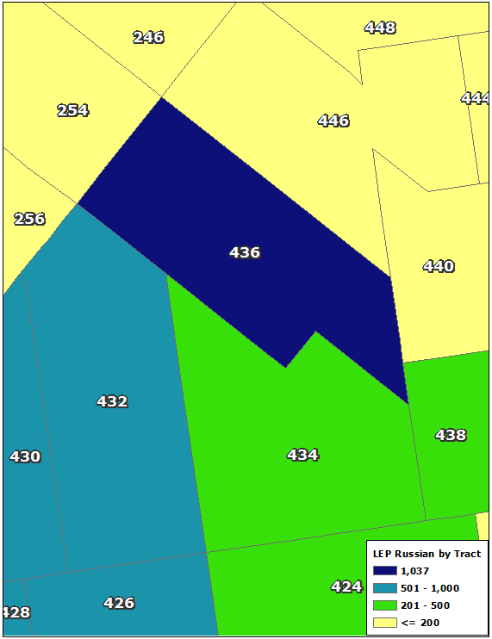
Figure 1: Russian Speakers with LEP by Census Tract (American Community Survey 2011-2015 5-Year Sample).

- To move from the Census tract to the Election District level, the City mapped the City Board of Elections’ Election District geographic boundaries on to the Census tracts. Figure 2 shows Election Districts mapped on the Census tracts pictured in Figure 1. Census tract 436 overlaps with three Election Districts: 48036, 48043, and 48044.
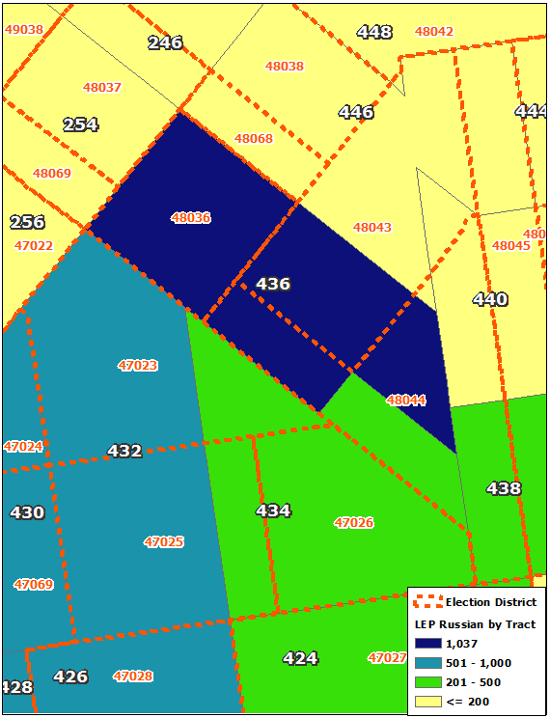
Figure 2: Election District boundaries overlaid on ACS Census tract-level Russian speakers with LEP estimates.

- The City then overlaid geocoded registered-voter addresses on the map of Census tracts and Election Districts. This allowed the City to identify the proportion of voters within the Census tract that should be allocated to each Election District within the Census tract.
- As shown below in Figure 3, the three Election Districts that overlap Census tract 436 each contain a fraction of the total number of voters in the tract. Once voter addresses were geocoded onto the map, the 1,034 Russian speakers with LEP in Census tract 436 could be allocated to the three overlapping Election Districts based on the percentage of voters in Census tract 436 that were located in each Election District.

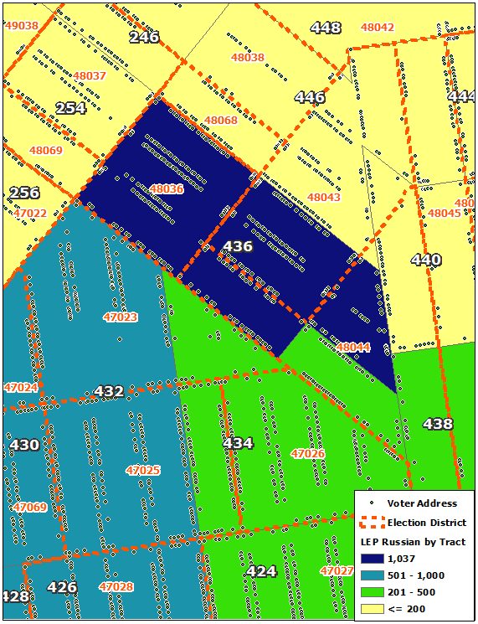
Figure 3: Election District boundaries and ACS Census tract Russian speakers with LEP estimates overlaid with geocoded voter addresses.
- Once the same process was applied to all Census tracts, the estimates for each Census tract could be aggregated by Election District. Figure 4 below shows that Election District 48036 has an estimated 507 Russian speakers with LEP, while the surrounding Election Districts have fewer Russian speakers with LEP.
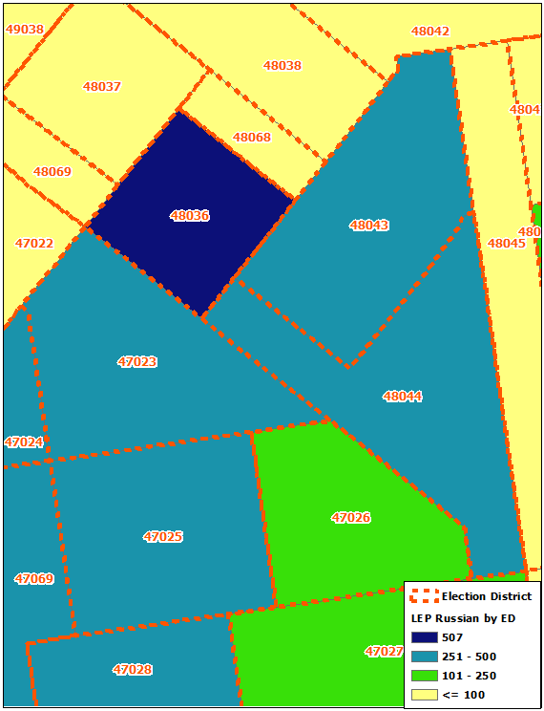
Figure 4: Russian Speakers with LEP by Election District.
- Most poll sites serve multiple Election Districts. In order to estimate the LEP population by language at each poll site, the City reviewed lists published by the City Board of Elections that show the Election Districts assigned to each poll site. The City then summed the Election District level data for each poll site.
- As shown in Figure 5, the poll site for Election District 48036 is P.S. 226, located at 6006 23rd Avenue, Brooklyn. There are eight other Election Districts assigned to this poll site: 48037, 48038, 48043, 48044, 48045, 48051, 48068, and 48069. The nine Election Districts that vote at P.S. 185 contain an estimated total of 1,501 Russian speakers with LEP.
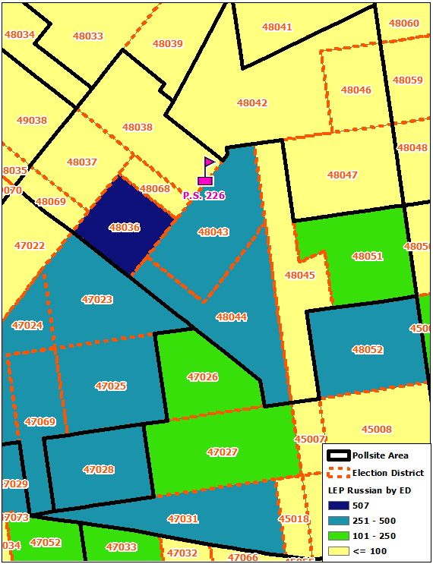
Figure 5: P.S. 226 and its surrounding Election Districts.
- Once the City had poll site level data for language spoken at home and LEP status, it still needed to perform a series of adjustments to estimate the number of LEP language-speakers at each poll site who were also eligible voters — i.e., who were citizens and 18 or older. To make these adjustments, the City searched the American Community Survey data set for the top languages, English proficiency, age, and citizenship status by PUMA. The City then determined what percentage of speakers of the languages most commonly spoken among citizens of voting age who have LEP in each PUMA were also eligible voters. The City used the PUMA level percentages to make proportionate adjustments to the poll site-level estimates to account for voting eligibility.
- The poll site pictured in Figure 5, P.S. 226, is located in PUMA 4014. According to the 2017 American Community Survey, 72.7% of the Russian speaking with LEP population in PUMA 4014 were citizens age 18 or over. The estimate of 1,501 Russian speakers with LEP derived using the process described above was therefore adjusted using the above ratio, to produce a final estimate of 1,091 Russian speaking citizens with LEP age 18 and over eligible to vote at P.S. 226.

https://www1.nyc.gov/site/civicengagement/meetings/meeting-notice.page
The Charter was then revised to include Chapter 76, which governs the NYCCEC.
The ACS is a yearly national survey of 3.5 million households. It is conducted by the U.S. Census Bureau.
2013-2017 American Community Survey 5 Year Estimates, U.S. Census Bureau, https://factfinder.census.gov/faces/tableservices/jsf/pages/productview.xhtml?src=CF (last visited December 15, 2019).
The ACS three questions to assess languages spoken by each person who lives in the home: whether people speak a language other than English; if yes, which language they speak; and how well they speak English. The question about English proficiency states: “How well does this person speak English?” People can answer “Very well,” “Well,” “Not well” or “Not at all.” U.S. Census Bureau, https://www2.census.gov/programs-surveys/acs/about/qbyqfact/Language.pdf (last visited December 15, 2019). A study compared answers for this question from the 2003 ACS to the 2003 National Assessment of Adult Literacy (NAAL) and found that people who answered “very well” on ACS tended to have very similar profiles as English only speakers on the NAAL, suggesting that this ACS English ability question is a valid measure of English proficiency. U.S. Census Bureau, https://www.census.gov/library/working-papers/2015/demo/SEHSD-WP2015-18.html (last visited December 15, 2019).
ACS asks of each person in the home: Is this person a citizen of the United States? U.S. Census Bureau, https://www.census.gov/acs/www/about/why-we-ask-each-question/citizenship/ (last visited December 15, 2019).
One site served both Russian and Arabic speaking LEP voters and is thus counted only once in the total 101 sites covered by MOIA’s program.
Census tract is an area roughly equivalent to a neighborhood, roughly 4000 people.
The data presented in this document uses the latest 2017 U.S. Census American Community Survey (ACS) 1-year Public Use Microdata Samples (PUMS). We anticipate updating the data presented here with 2018 5-year PUMS once that becomes available on January 30, 2020. Using the 5-years estimates increases the statistical reliability of the data compared with that of single-year estimates, particularly for small geographic areas and small population subgroups. Note that this may adjust the number of languages in which the NYCCEC will provide interpretation. For additional information on the PUMS data, please see U.S. Census Bureau, “Public Use Microdata Sample (PUMS) Documentation” (2019), available at https://www.census.gov/programs-surveys/acs/technical-documentation/pums.html
https://www1.nyc.gov/assets/immigrants/downloads/pdf/Local_Law_30.pdf (Local Law 30 Report, 2019)
U.S. Census Bureau, 2017 ACS 1-Year Estimates - Public Use Microdata Samples
As mentioned earlier, the data presented in this document uses the latest 2017 U.S. Census American Community Survey (ACS) 1-year Public Use Microdata Samples (PUMS). We anticipate updating the data presented here with 2018 5-year PUMS once that becomes available on January 30, 2020.
PUMA level is approximately the size of a community board district.
Surname analysis is a technique utilized by demographers to identify the members of particular racial, ethnic, or language communities within a population, insofar as a surname belongs uniquely to a particular racial or ethnic group, often referencing well-formulated surname dictionaries. Abrahamse, A.F., Morrison, P.A. & Bolton, N.M. Surname analysis for estimating local concentration of Hispanics and Asians. Popul Res Policy Rev 13, 383-390 (1994).
20,615 votes in last weekend vs. 12,522 in first weekend in NYC EV. https://vote.nyc/important-notices/early-voting-check-ins.

