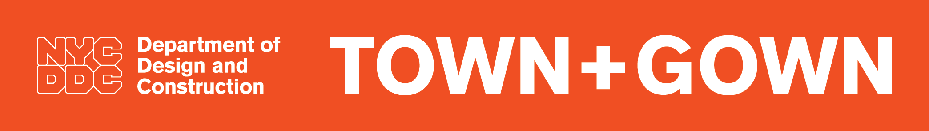

What can Town+Gown do for members of Gown?
- Provide a comprehensive and coherent City-wide research agenda with real and relevant questions for use by experiential and in-service learning programs to develop capstone projects, workshops, studios, law clinics and internships, and by professors in developing courses, case studies, and academic research projects.
- Bridge the divide between academics and practitioners for experiential and in-service learning programs.
- Provide a Letter of Collaboration to researchers or grant proposals (e.g., NSF, NIST)
- Make introductions and help manage relationships with practitioner partners on projects from project inception to peer review.
- Provide opportunities for academics to engage with public policy makers on place- and data-based inquiries and analyses.
- Increase exposure of applied academic work product among practitioners.
- Publish Building Ideas annually, which presents the work of academic programs to a wider audience of built environment practitioners.

