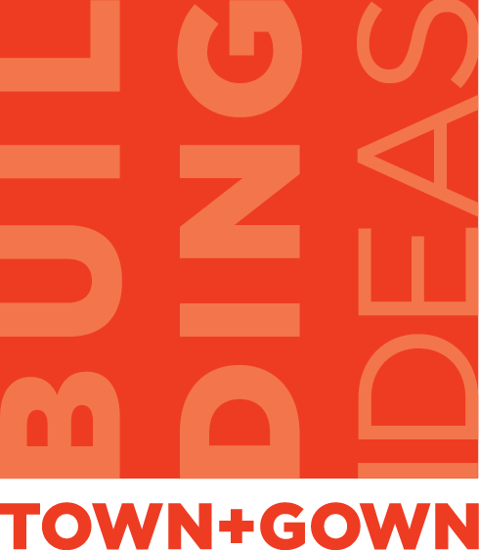
Design: Just What the Heck Is It?
A Town+Gown event
in collaboration with the AIANY/Center for Architecture
presented in association with Archtober, Architecture and Design Month, New York City
October 17, 2012, 8:30 to 11:00 a.m.
Agenda

8:30-8:45—Registration/Introduction

8:45-9:30—Panel 1

CREATES JOBS

  - Katie Codey, New York City Council
  - Alison Hodgson, New York City Economic Development Corporation
  - David Giles, Center for Urban Future

  - Moderator: Ronnie Lowenstein, New York City Independent Budget Office

9:30-10:15—Panel 2

CHANGES PUBLIC SERVICES

  - James Biber, Biber Architects
  - Sharun Goodwin, New York City Department of Probation
  - Laura Kurgan, Columbia University Graduate School of Architecture, Planning and
Preservation
  - Susan Tucker, New York City Department of Probation
  - Lonni Tanner, New York City Department of Design and Construction/SeeChangeNYC
  - James Victore, James Victore, Inc.

  - Moderator: David Burney, New York City Department of Design and Construction

10:15-11:00—Panel 3

IMPROVES QUALITY OF URBAN LIFE

  - Karrie Jacobs, School of Visual Arts
  - Chelsea Mauldin, Public Policy Lab
  - Mark Randall, WorldStudio
  - Willy Wong, NYC+Co
  - Moderator: Laetitia Wolff, DesigNYC

