GLOBAL NYC 2018: CITY LEADERSHIP ON THE RISE
NYC Mayor’s Office for International Affairs

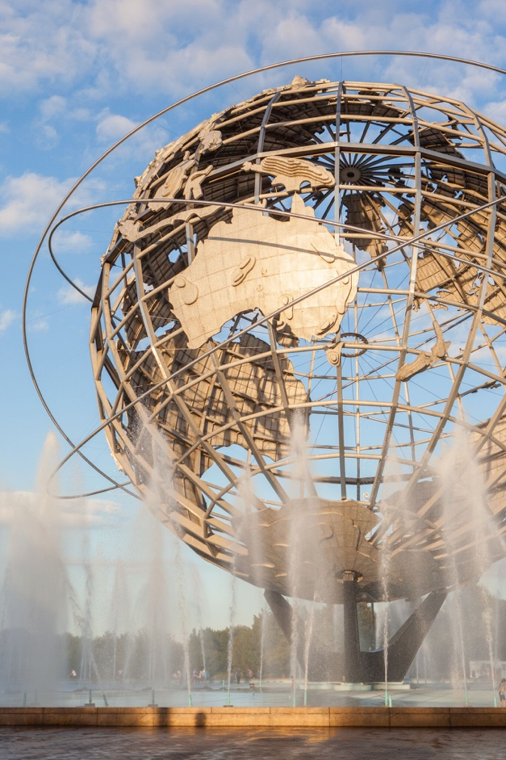
[IMAGE] The Unisphere in Queens, a metal globe structure with a fountain underneath.

Table of Contents
Mission and History 2
Message from Commissioner Penny Abeywardena 3
A New Era for City Diplomacy and Global Engagement 3
The Global City 4
NYC and the United Nations 5
Engaging the Diplomatic and Consular Community 6
Connecting Local to Global 6
Services 6
City Leadership on Global Challenges 7
Global Mayors Summit on Migration and Refugees 8
Global Vision | Urban Action: Translating the SDGs Locally 8
Building Global Citizens 9
NYC Junior Ambassadors Program 10
Economic Development 12
Inclusive, Sustainable and Good for All New Yorkers 12
GlobalNYC Impact 13
Contact Us 16

Mission and History
The New York City Mayor’s Office for International Affairs serves as a global platform from which the City Promotes its goals for a more just and equitable society, showcases the diversity of New Yorkers, and exchanges policies and best practices with the international community.

Established in 1962 as the New York City Commission for the United Nations to serve as a liaison between the diplomatic community and local residents, businesses, and government, the Office has evolved not only in name, but in function and purpose over more than 50 years of service to New Yorkers and the international community.

In all its work, the New York City Mayor’s Office for International Affairs strives to foster positive relations and collaboration between the City, its residents, and the largest diplomatic community in the world represented by 193 Permanent Missions to the United Nations, 115 Consulates, the United Nations headquarters, and United Nations affiliates.

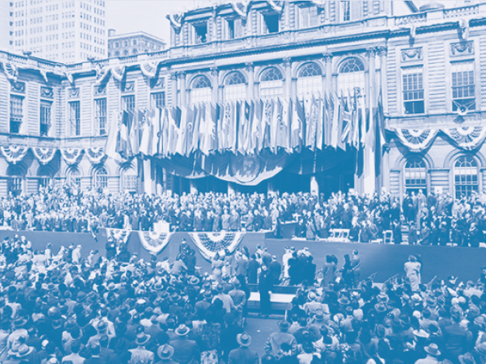

[IMAGE] Black and white photo of crowded UN
Delegates gathered at City Hall during the first year of the UN in NYC, October 1946.

Message from Commissioner Penny Abeywardena

[Quote] "As host and partner to the United Nations, New York City is uniquely positioned to act on the shared global challenges of our time. While some national governments retreat from this urgent responsibility, in our second term, we will increase engagement to show the world that the New York City values of inclusion, fairness and cooperation represent the best of American values." – COMMISSIONER PENNY ABEYWARDENA

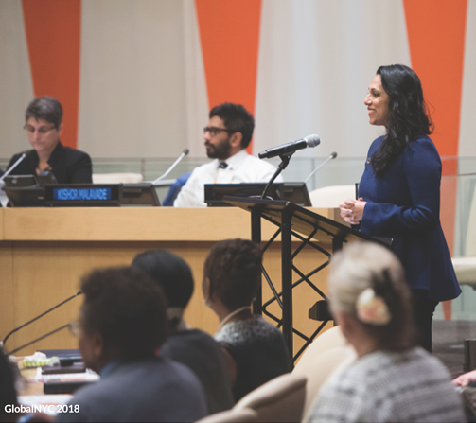
[IMAGE] Commissioner Penny Abeywardena stands at a metal podium and addresses a Global Vision |Urban Action event on mental health hosted by the Mayor’s Office for International Affairs at the UN in January 2017.

A New Era for City Diplomacy and Global Engagement

As I reflect on my first term as Commissioner of the Mayor’s Office for International Affairs and look forward to the next four years, I am grateful for everything we have accomplished together, and energized by our potential to make an impact at this critical moment for our City and the World. Since Mayor Bill de Blasio appointed me in 2014, this Office has transformed into a global platform from which our City promotes its goals for a more just and equitable society, showcases the diversity of New Yorkers, and exchanges policies and best practices with the international community. I have met with hundreds of international leaders, and my team has arranged hundreds of meetings between visiting foreign delegations and City agencies to foster collaboration on shared priorities. We have launched innovative new programs while providing essential services to the world’s largest diplomatic community – 193 Permanent Missions, 115 Consulates, and the headquarters of the United Nations – and 74 trade missions that call New York City home.

New York City and the international community enjoy a special relationship, where more than one-third of our 8.5 million residents are foreign born. This report highlights our work to provide the diplomatic community with opportunities to engage the vibrant tapestry of our global city, and to connect the diverse communities represented by our consular corps with the vital services offered by our City agencies. The following pages also showcase our efforts to educate New Yorkers about the significant economic and cultural benefits of hosting the United Nations, and to streamline processes and information to help international and local entrepreneurs grow their businesses inclusively and create opportunities for New Yorkers with our economic development work.

As host and partner to the United Nations, New York City is uniquely positioned to act on the shared global challenges of our time. While some national governments retreat from this urgent responsibility, in our second term, we will increase engagement to show the world that the New York City values of inclusion, fairness and cooperation represent the best of American values. In the past year alone, we are proud that New York City has remained committed to the Paris Agreement, and hosted the first-ever Global Mayors Summit on Migration and Refugees during the 72nd UN General Assembly.

With most of the world’s population now living in urban areas, city leadership is indispensable to solving global issues. The following pages show how our Global Vision | Urban Action program works to translate the Sustainable Development Goals into concrete action in our local communities. We also believe that youth must be part of the solution, and through our flagship program, NYC Junior Ambassadors, we have already reached nearly 1,000 students and educators in over 50 classrooms to build global citizens empowered to take action in their local communities.

In the coming years, I encourage you to approach my Office as a resource and partner. Please feel free to reach out, and join the conversation on our growing social media channels. I am encouraged by the foundation we have built together, and excited to see what progress we will continue to make.

Best regards, [Signature] Penny Abeywardena

The Global City

Cities matter, now more than ever. The United Nations projects that by 2030, more than two-thirds of the world’s population will live in cities. Urban centers like New York City are critical not just for global growth, but as hubs of culture, creativity and innovation.

We are a city of immigrants—the five boroughs of Manhattan, Brooklyn, Queens, the Bronx, and Staten Island are home to more than 8.5M people who speak over 800 languages.

New York City is also home to the largest diplomatic and consular community in the world, with 193 Permanent Missions, 115 Consulates, 75 trade missions, and the permanent headquarters of the United Nations.

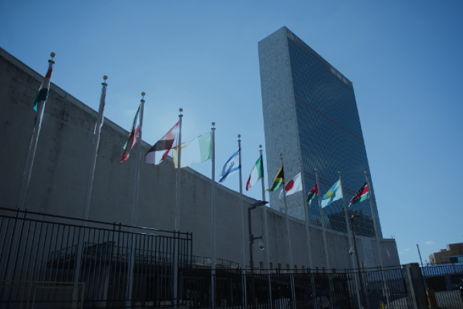

[IMAGE] A view of the United Nations headquarters. Several member states flags are flying under a blue sky with the Secretariat building in background.

NYC and the United Nations

The special relationship between New York City and the United Nations is an invaluable resource for local residents, City agencies, businesses, and the diplomatic community. New Yorkers and the UN share more than a city, we share a vision for a more just, sustainable and fair world.

[Quote] “I am privileged, as Secretary-General, to be able to live in New York because it’s where the UN headquarters are. It’s a vibrant city, but it’s not only an economic, financial capital in today’s world, it’s a city with a remarkable diversity and the policy to have this diversity.” – UN SECRETARY-GENERAL ANTÓNIO GUTERRES

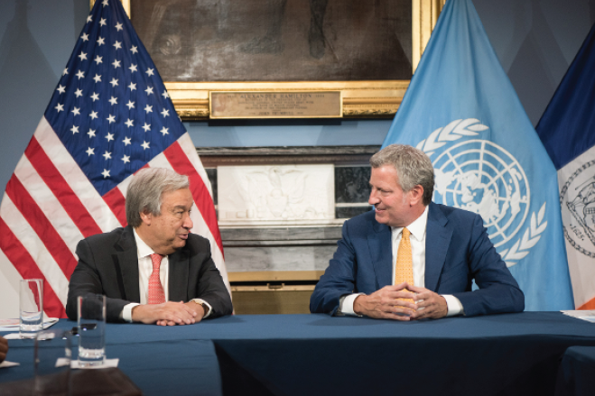

[IMAGE] Secretary-General António Guterres sits left at a table with Mayor Bill de Blasio sitting on the right. The two are pictured at New York City Hall in Aug 2017. Behind them are an American flag on the left and a UN flag on the right.

Engaging the Diplomatic and Consular Community

Connecting Local to Global
Our Connecting Local to Global program integrates the world’s largest diplomatic and consular community with the City in which they live and serve, helps City agencies amplify their work to immigrant communities represented by the diplomatic community, and arranges opportunities for collaboration and best-practice sharing. From holiday toy drives, volunteer days, and workshops on housing rights and responsibilities for diplomats, to name a few, the diplomatic community and the City enrich each other.

Services
Our Office provides critical services and information to support the diplomatic and consular community in accomplishing its important work. We respond to diplomatic incidents and emergency situations, administer the City of New York/U.S. Department of State Diplomatic and Consular Parking Program, and manage requests from foreign governments, the United Nations and the U.S. Department of State. We also work with the New York City Police Department, the State Department, U.S. Secret Service, United Nations, and other partners to ensure the safety of all New Yorkers during the high-level meeting of the UN General Assembly each September, and on other occasions year-round.

UN Impact Report

For the first time in two decades, the Mayor’s Office for International Affairs, in collaboration with the New York City Economic Development Corporation, released a cost-benefit analysis of hosting the United Nations in New York City. Our UN Impact Report 2016 showed that the UN community contributed #3.69 billion in total economic output to the City of New York, with approximately $56 million in net fiscal benefits – in addition to the immeasurable value of the UN as a cultural and educational resource for New Yorkers.

IDNYC @ The United Nations

Like many NYC residents, our UN colleagues working here hail from all corners of the world. Our Office partnered with the UN Secretary-General’s office to host an IDNYC pop-up registration site on the UN campus to assist UN staff and delegates in obtaining IDNYC cards. This exciting collaboration took one of Mayor de Blasio’s signature programs to the halls of the United Nations and showed that members of the diplomatic community who are foreign nationals are also New Yorkers. We had over 1,700 new IDNYC registrants, including former UN Secretary-General Ban Ki-moon.

[Quote] “The City of New York has been a warm, welcoming, and hospitable host to the diplomatic community and through initiatives like the Secret Snowflake program organized by the Mayor’s Office for International Affairs, we at the Singapore Permanent Mission to the United Nations and Singapore Consulate in New York have the opportunity to share and spread the warmth and year-end festive cheer to the needy children of this wonderful city.” – CONSUL EUGENE NG OF THE CONSULATE OF THE REPUBLIC OF SINGAPORE IN NEW YORK, ON PARTICIPATION IN THE HOLIDAY TOY DRIVE
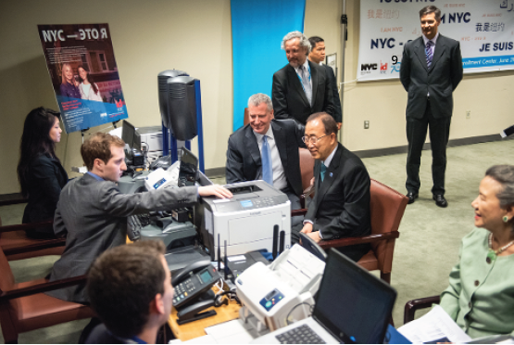

[IMAGE] Former UN Secretary-General Ban Ki-moon sits in an office chair across from a city agent to register for his IDNYC card with Mayor Bill de Blasio sitting to the left next to him.

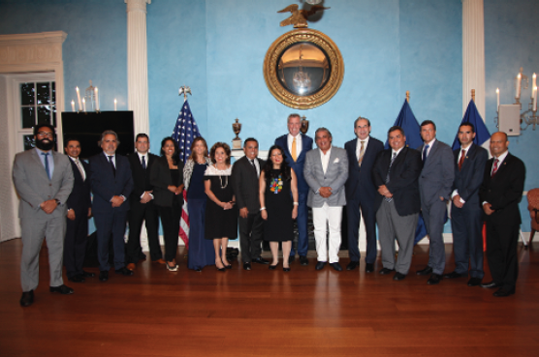

[IMAGE] A group of representatives from the Coalition of Latin American Consuls in New York (CLACNY) met with Mayor Bill de Blasio in the middle. Picture taken at Gracie Mansion in August 2017.

City Leadership on Global Challenges

Global challenges today are transnational and shared, from climate change to migration to economic inequality, and more. With rising urbanization, cities are on the frontlines of the issues, and urban centers are the innovative drivers of solutions. Cities are rising at a time when many national governments are retreating from leadership.

The Mayor’s Office for International Affairs is convening conversations on pressing global issues to strengthen networks among policymakers, empower citizens to take action, and show the world that our New York City values of inclusion, fairness, and cooperation represent the best of American values.

[Quote] “For too many of us, we see our national governments less able to respond to changing dynamics than ever before or less willing to, in so many cases, particularly on issues of migration. The default position is to let the cities handle it. And we know an essential truth. We handle these issues because it is our job. It’s our moral responsibility, because if there are human beings in our midst, they become part of our community.” – MAYOR BILL DE BLASIO

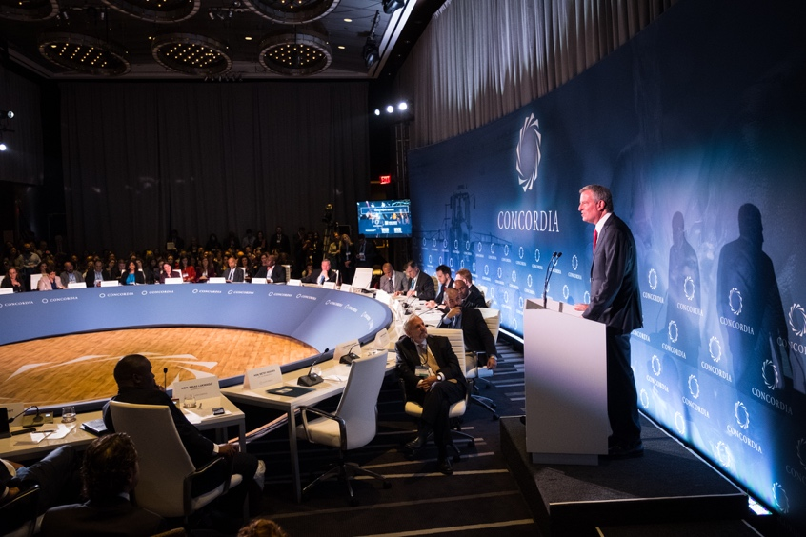

[IMAGE] Mayor Bill de Blasio stands at a podium before a circular panel to deliver keynote address to the Global Mayors Summit on Migration and Refugee Policy and Practice in September 2017.

Global Mayors Summit on Migration and Refugees

New York City leveraged our role as home of the United Nations to host the first-ever Global Mayors Summit on Refugee and Migration Policy and Practice during the 72nd UN General Assembly in 2017. Our summit kickstarted dialogue on how cities, which often serve as the front line for meeting newly arrived migrant and refugee needs, can create longer-term urban policies that foster diversity and inclusion.

More than 50 global city representatives, and dozens of civil society, private sector and international stakeholders joined our Office and co-hosts the NYC Mayor’s Office of Immigrant Affairs, Concordia, Columbia University Global Policy Institute, Open Society Foundations, and the International Peace Institute for this important conversation.

Global Vision | Urban Action: Translating the SDGs Locally

Our Global Vision | Urban Action program highlights the synergies between the UN Sustainable Development Goals (SDGs) and the OneNYC, the City’s groundbreaking plan for inclusive and sustainable growth. Our Office brings together experts and representatives from NYC and the international community to advance the SDGs at the local lever, on topics ranging from mental health, to water management, to decent work for all.

World leaders gathered at the United Nations in 2015 to commit to a set of goals to end extreme poverty, fight inequality and injustice, and address climate change by 2030. These Sustainable Development Goals apply to all countries, and as the leading global city in the United States, New York City is showing how to translate the 17 ambitious goals into concrete actions.

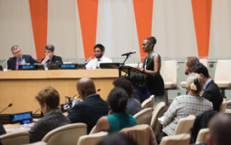

[IMAGE] First Lady of New York City Chirlane McCray stands at podium to deliver keynote to Global Vision | Urban Action event on mental health, addressed in SDG 3, at the UN in January 2017.

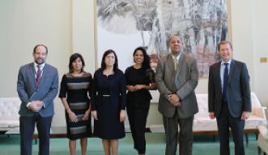

[IMAGE] Speakers at the Global Vision | Urban Action event on SDG 8 (Decent Work) stand with Commissioner Penny Abeywardena in the middle.

Building Global Citizens

The world today has the largest population of young people in history at more than 1.8 billion. Youth hold enormous potential for global progress, while their generation will be most affected by the outcome of our response to unprecedented transnational challenges such as climate change, inequality, and migration.

The common promise of humanity depends on how we engage young people at this moment. Our Office is committed to investing in the youth population on whom the future rests. Young people are more connected than ever before because of developments in technology, and if solutions to global issues are to be inclusive and sustainable, then youth must be part of the effort.

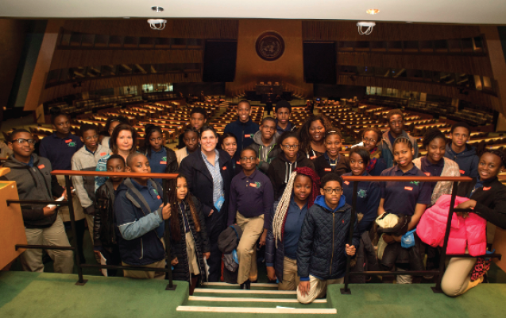

[IMAGE] Staff and students from Brooklyn Science and Engineering Academy stand in the General Assembly Hall of the UN.

NYC Junior Ambassadors Program

This one-of-a-kind program leverages the special relationship between New York City and the United Nations to make a difference for tomorrow by building the next generation of global leaders. The program educates young people about the role they play in the world, and equips them with tools to take action on global issues starting in their own local neighborhoods.

Students become actively engaged with the United Nations and its mission of addressing the most pressing challenges in the world. Classes incorporate the United Nations and its Sustainable Development Goals into their curriculum, on subject areas from science to arts to language. Each participating class receives a curated tour of UN headquarters tailored to their curricular interest, and a classroom visit from a senior diplomat.

Since 2015, the New York City Junior Ambassadors program has reached over 50 classrooms and touched the lives of nearly 1,000 seventh-grade students and educators, in partnership with the NYC Department of Education, the Department of Youth and Community Development, the United Nations, and the United Nations Foundation.

In addition to planned programming, NYC Junior Ambassadors engage in special activities and events with global and local leaders. Some of the opportunities have included speaking alongside heads of state and UN leaders at the first-ever UN Ocean Conference and the 2017 World Children’s Day Summit at the UN, attending the 70th Celebration of the Human Rights Declaration at the UN, and media interviews.

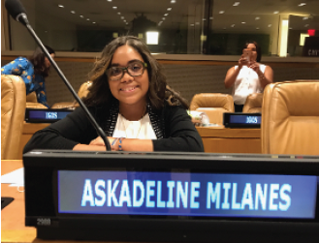

[IMAGE] NYC Junior Ambassador Askadeline Milanes sits at a UN panel about the importance of youth involvement in the SDGs.

[Quote] “[Climate change is] a real problem considering that animal habitats around the world are getting destroyed. We should be able to help, but instead we are ignoring the problem and running away. That’s not going to help. You have to be a part of it.” – ASKADELINE MILANES, MEMBER OF THE 2016-2017 NYC JUNIOR AMBASSADORS COHORT, AS SPOKEN TO THE NEW YORK DAILY NEWS

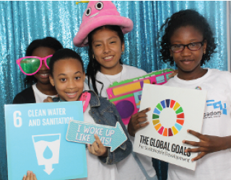
[IMAGE] Four NYC Junior Ambassadors pose in a photo booth at the year-end celebration for the 2016-2017 cohort.

[Quote] “I believe that I can inspire one person to stop using plastic water bottles, one person to stop using plastic bags and instead use recyclable bags, that’d be huge. I believe we can make a difference in this world. All we have to do is change people’s mindset; you can be the start of change.” – FATOUMATA CISSE, CLIMATE ACTIVIST FROM THE SOUTH BRONX AND MEMBER OF THE 2016-2017 NYC JUNIOR AMBASSADORS COHORT, AS SPOKEN TO TEEN VOGUE

Economic Development

Inclusive, Sustainable and Good for All New Yorkers

One of the most diverse and dynamic economies in the world, New York City is home to 75 trade missions and many innovative industries. The Mayor's Office for International Affairs works with the diplomatic community, businesses and City agencies to attract and create economic opportunities for New Yorkers. Our office assists international businesses and startups that want to enter New York, and helps New York City-based businesses and startups interested in selling internationally.

As a connector, our Office has streamlined processes and resources for international businesses interested in expanding to New York City, linked businesses with government programs available to them, and shared economic best practices between the City, United Nations, and the world.

[Text Box] Making Connections

- In 2016, the Mayor's Office for International Affairs and the NYC Economic Development Corporation (NYCEDC) developed a website to provide a one-stop resource for international businesses considering growing their business in NYC: nyc.gov/internationalbusiness

- In 2016, the Office created a connector between the employer pipeline of international startups coming into NYC and the employee pipeline of New Yorkers graduating from the NYC Tech Talent Pipeline.

- In 2017, the Mayor's Office for International Affairs and NYCEDC brought international economic representatives from 25 countries to tour two spaces supporting entrepreneurs, international startups and tech companies at the Brooklyn Navy Yard.

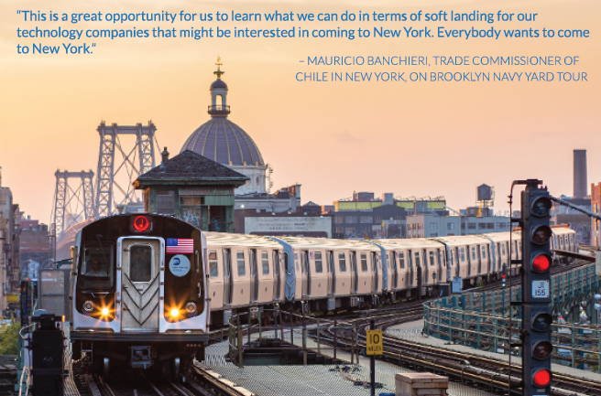

[IMAGE] The J subway train is on the tracks pulling into an above-ground station. The following text is on top of the picture in blue text:

[Quote on picture] “This is a great opportunity for us to learn what we can do in terms of soft landing for our technology companies that might be interested in coming to New York. Everybody wants to come to New York.” – MAURICIO BANCHIERI, TRADE COMMISIONER OF CHILE IN NEW YORK, ON BROOKLYN NAVY YARD TOUR

GlobalNYC Impact

The Mayor's Office for International Affairs takes pride in the impact of our work for the diplomatic and consular community, City agencies, New Yorkers, and international and NYC businesses. Here are just a few measures of the value we bring for our partners.

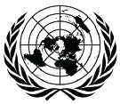

[IMAGE] UN logo

- Collaborated with the NYC Economic Development Corporation on UN Impact Report showing that the UN community contributes $3.69 billion in total economic output to NYC

[IMAGE] IDNYC symbol
- In partnership with the Mayor's Office of Immigrant Affairs, trained more than 130 consulate representatives on IDNYC, reaching communities that stand to benefit most from this resource

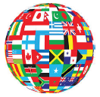
[IMAGE] A globe covered in images of flags from countries around the world.
- Facilitated meetings and connections for hundreds of visiting delegations with City agencies, including approximately 300 delegations from 83 countries in 2017

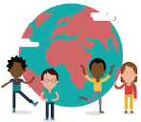

[IMAGE] A diverse group of animated characters stand in front of a pink and turquoise globe.
- Transformed nearly 1,000 NYC 7th grade students and educators from more than 50 classrooms into global citizens acting locally through the NYC Junior Ambassadors Program

[IMAGE] A cartoon lightbulb in a circle.
- Helped over 60 international businesses expand into NYC and assisted 29 NYC-based businesses with plans to expand internationally, and held 69 meetings with international economic representatives

[IMAGE] Animated hands, all a different color of the rainbow, reaching into middle to create circle
- Hosted nearly 40 events to connect the diplomatic community with the City, including opportunities to provide service to fellow New Yorkers

[IMAGE] Stick figure speaking behind a podium with audience, surrounded by a dotted-line circle
- Organized 3 major summits for international city leadership, drawing over 70 senior leaders from more than 100 cities

[IMAGE] Different social media logos covering a sphere
- Launched 4 social media platforms with more than 8,100 followers and growing

[IMAGE] Purple stick figure holding a box with a heart on it, in a purple circle
- Coordinated diplomatic and consular community participation in 3 holiday toy drives to benefit over 600 New Yorkers in need

Contact Us
NYC Mayor’s Office for International Affairs

Mailing Address:
2 United Nations Plaza, 27th Floor
New York, NY 10017

Telephone: 212.319.9300
Website: nyc.gov/international
Twitter: @globalnyc
Facebook: https://www.facebook.com/NYCMayorsInternationalAffairs
Instagram: @nycinternationalaffairs
Medium: @GlobalNYC

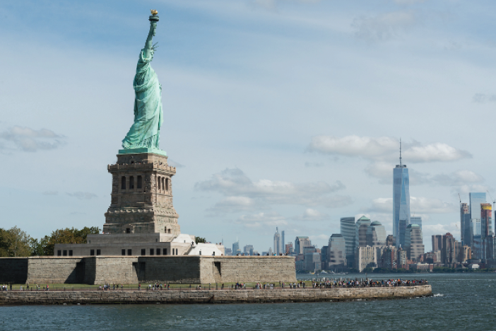
[IMAGE] View of the entire Statue of Liberty from the side.

