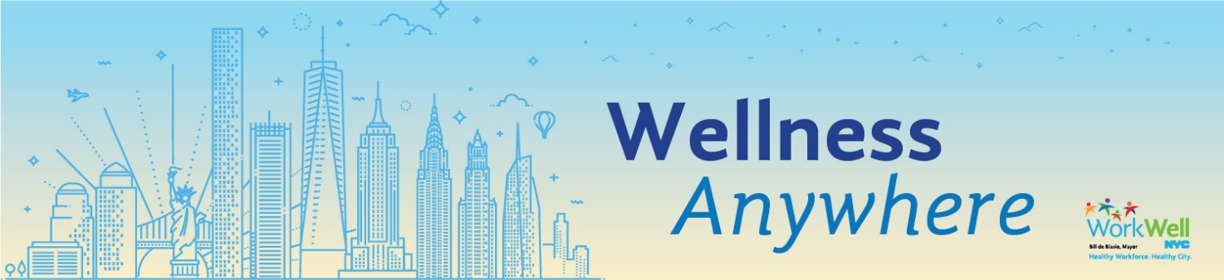

General Health:
Wash your Hands
Practicing Social Distancing
Enjoy NYC Parks at Home
Eat Healthy, Be Active NYC Facebook Group
COVID-19: General Guidance for Cleaning and Disinfecting for Non-Health Care Settings
COVID-19: General Guidance for Vehicle Operators
COVID-19 Guidance for People Who Use Drugs
Safer Sex During COVID-19
COVID-19 and People with HIV
Move More (Physical Fitness) Slack Community
Eat Well (Healthy Eating) Slack Community
Staying Sober During the COVID-19 Outbreak

Mental Health:
Be Well (Mental Health) Slack Community
Coping with Stress During an Infectious Disease Outbreak
Stress Reduction Tips
Finding Calm in a Crisis
Managing COVID-19 Stress among Healthcare Workers
Protecting your Mental Health During COVID-19
Mental Health Support New Yorkers Can Access While Staying Home
Mental Health Support for Those with Cancer
Dealing with Isolation and Loneliness
NYC EAP
NYC EAP Caretaker Burnout

Financial Health:
Financial Help for People With Cancer
Food Delivery Assistance
HRA Cash Assistance

For Parents:
COVID-19 and Pregnancy/Breastfeeding
COVID-19 and Children
Talking to Kids about the Coronavirus
COVID-19 Information for Parents of School-aged Children

Workplace Health:
COVID-19 Guidance for Businesses and Other Non-Health Care Settings
Resources for Businesses and Employers
Working from Home Ergonomics
Staying Calm Under Pressure: Dealing with Difficult Situations at Work

Events:
COVID-19 and Cancer Workshop

